**PROJECT REPORT**

**ON**

**VIRTUAL AI CAREER ADVISOR**

**Project - I**



DEPARTMENT OF COMPUTER SCIENCE AND ENGINEERING

**CHANDIGARH ENGINEERING COLLEGE JHANJERI, MOHALI**

**In partial fulfillment of the requirements for the award of the Degree of Bachelor of Technology in Computer Science & Engineering**

**SUBMITTED BY: Under the Guidance of**

Team Member 1 - Nikhil Kumar (2230813) Ms. Jaspreet Kaur

Team Member 2 - Gaurav Sharma (2230771) Assistant Professor(CSE)

Team Member 3 - Jitesh Jaswal(2230784)

Team Member 4 - Konal Sharma(2230789)

MAY, 2025



**Affiliated to I.K Gujral Punjab Technical University, Jalandhar**

**(Batch: 2022-2026)**

**DECLARATION**

I, Nikhil Kumar, Gaurav Sharma, Konal Sharma, Jitesh Jaswal hereby declare that the report of the project entitled “Virtual AI Career Advisor” has not presented as a part of any other academic work to get my degree or certificate except Chandigarh Engineering College Jhanjeri, Mohali, affiliated to I.K. Gujral Punjab Technical University, Jalandhar, for the fulfillment of the requirements for the degree of B.Tech in Computer Science & Engineering.

**NIKHIL KUMAR (2230813) Ms. Jaspreet Kaur**

**GAURAV SHARMA (2230771)** Assistant Professor, CSE

**KONAL SHARMA(2230789)**

**JITESH JASWAL(2230784)**

Semester: 6

**Dr. Rini Saxena**

**H.O.D CSE**

**ACKNOWLEDGEMENT**

It gives me great pleasure to deliver this report on Project-I, which I worked on for my B.Tech in Computer Science & Engineering 3rd year, which was titled "Virtual AI Career Advisor “. I am grateful to my university for presenting me with such a wonderful and challenging opportunity. I also want to convey my sincere gratitude to all coordinators for their unfailing support and encouragement.

I am extremely thankful to the HOD and Project Coordinator of Computer Science & Engineering at Chandigarh Engineering College Jhanjeri, Mohali (Punjab) for valuable suggestions and the heartiest cooperation.

I am also grateful to the management of the institute and Dr. Avinash, Director Engineering, for giving me the chance to acquire the information. I also appreciate all of my faculty members, who have instructed me throughout my degree.

**Nikhil Kumar**

**Gaurav Sharma**

**Konal Sharma**

**Jitesh Jaswal**

**TABLE OF CONTENTS**

**PARTICULARS Page No.**

Title Page i

Declaration by the Candidate ii

Acknowledgement iii

Table of Contents iv - vii

Abstract viii

List of Figures ix

List of Tables x

**CHAPTER 1 - INTRODUCTION 1 - 8**

* 1. Scope of the Project 1 - 2
  2. Background and Motivation 2 - 3
  3. Problem Definition 3 - 4
  4. Objectives of the Project 4
  5. Methodology 4 - 6

1.5.1 Requirement Gathering & Research 5

1.5.2 System Design 5

1.5.3 Technology Stack 6

1.5.4 Backend API Creation 6

1.5.5 Frontend Integration 6

1.5.6 Testing and Deployment 6

1.6 Tools and Technologies Used 7

1.7 Organization of the Report 8

**CHAPTER 2 – REVIEW OF LITERATURE 9 - 14**

2.1 Evolution of Career Guidance System 9 – 10

2.2 AI in Career 10

2.3 Resume Analysis and Vetting Systems 10 – 11

2.4 The Role of AI Chatbots in Career Assistance 11 - 12

2.5 Large Language Models (LLMs) in Education and Career Tech 12

2.6 Importance of Real-Time Job Trend Analysis 13

2.7 Summary of Key Literature Insights 13

2.8 Summary 14

**CHAPTER 3 - PROBLEM DEFINITION AND OBJECTIVES 15 – 23**

3.1 The Problem Space 15 – 16

3.1.1 The Disconnect Between Education and Employment 15

3.1.2 Limited Access to Personalized Counseling 15

3.1.3 Inadequate Resume and Skill Analysis 16

3.1.4 Confusing Job Market Trends 16

3.2 Existing Solutions and Their Shortcomings 16 -17

3.2.1 Manual Counseling 16

3.2.2 Online Psychometric Tools 16

3.2.3 Resume Builders 16

3.2.4 Career Portals (e.g., LinkedIn, Indeed) 17

3.3 Statement of the Problem 17 -18

3.4 Purpose of the Study 18 –19

3.5 Project Objectives 19

3.6 Significance of the Study 19 -20

3.7 Scope of the Project 20 -21

3.8 Assumptions and Constraints 21 -22

3.9 Summary of Objectives 23

**CHAPTER 4 - DESIGN AND IMPLEMENTATION 24 – 53**

4.1 System Architecture Overview 24 – 25

4.2 Technology Stack 25 – 26

4.2.1 Frontend Technologies 26

4.2.2 Backend Technologies 26

4.2.3 AI/ML Integration 26

4.2.4 Supporting Tools & Packages 26

4.2.5 Development Tools 26

4.3 Functional Modules 27 – 28

4.3.1 Career Recommendation Module 27

4.3.2 Resume Vetter Module 27

4.3.3 Interactive Q&A Chatbot 27

4.3.4 Job Trends Module 28

4.4 Data Flow Diagram (DFD) 28 – 29

4.4.1 Level 0 DFD (Context-Level) 28

4.4.2 Level 1 DFD (Detailed Process Flow) 29

4.4.2.1. User Interaction 29

4.4.2.2. Processing Layer 29

4.4.2.3. AI-Based Career Analysis 29

4.4.2.4. Response Handling 29

4.5 User Interface Design 30 – 31

4.5.1 Homepage 30

4.5.2 Navigation Bar 30

4.5.3 Form Layouts 30

4.5.4 Chat Interface 30

4.5.5 Result Display 31

4.6 System Flowchart 31

4.7 Use Case Diagram 32

4.8 Backend Logic and API Integration 33

4.9 Technologies Used 34 -35

4.9.1 Frontend Technologies 34

4.9.2 Backend Technologies 34

4.9.3 External APIs & Tools 35

4.10 Code Implementation 35-53

4.10.1 Backend 35-41

4.10.2 Frontend 42-53

**CHAPTER 5 – RESULTS AND DECLARATION 54 – 59**

5.1 Home Page 54

5.2 Output of Career Recommendation Module 55

5.3 Output of Chatbot Assistant 56

5.4 Output of Job Trends Module 56

5.5 Output of Resume Vetting 57-58

5.6 User Interface and Experience 58

5.7 Discussion on Performance 59

**CHAPTER 6 - CONCLUSION AND FUTURE SCOPE 60 – 62**

6.1 Conclusion 60

6.2 Future Scope 61 – 62

**REFERENCES 63 - 64**

**ABSTRACT**

In today’s dynamic and competitive employment landscape, individuals often struggle to align their career paths with their skills, interests, and future market demands. This project introduces Virtual AI Career Advisor, a comprehensive web-based platform that leverages cutting-edge Large Language Models (LLMs) via the Groq API to deliver personalized, real-time career guidance. The system is built using a full-stack architecture with React.js for the frontend and FastAPI (Python) for the backend, ensuring seamless user experience and high performance.

The platform is equipped with multiple intelligent modules including Career Recommendation, Interactive Career Chat, Job Market Trends, and a recently integrated Resume-Vetter feature. The Career Recommendation engine analyzes user-inputted qualifications, skills, and preferences to generate customized career suggestions using Groq’s LLM. The Interactive Chatbot allows users to ask career-related questions and receive human-like responses. The Job Market Trends module uses live data to suggest in-demand jobs and tracks their growth potential. The Resume-Vetter allows users to upload resumes and job descriptions to receive a compatibility score and improvement tips based on AI analysis.

This work emphasizes the practical application of generative AI in career decision-making, combining Natural Language Processing (NLP) and machine reasoning to replace conventional static career portals. The system ensures modularity, scalability, and user-friendliness, aiming to support students, job seekers, and professionals in making data-driven career choices.

The platform has been evaluated through rigorous testing and simulated case studies, demonstrating high accuracy and relevance of its suggestions. Future enhancements include multilingual support, integration with real-time job APIs, and expansion into soft skill training. This research contributes significantly to the fields of AI in education and career development, showing how LLMs can be harnessed for social and professional empowerment.

Keywords: Career Recommendation, Groq API, Large Language Models, Resume Scoring, Job Market Trends, AI Chatbot, FastAPI, React.js, NLP.

**LIST OF FIGURES**

**Page No.**

5

25

28

29

31

32

54

55

55

56

56

57

58

**PARTICULARS**

Figure 1.1 : Working of Model

Figure 4.1 : Data Flow Diagram

Figure 4.2 : Level 0 DFD

Figure 4. 3 : Level 1 DFD

Figure 4.4 : System Flowchart

Figure 4.5 : Use Case Diagram

Figure 5.1 : Home Page

Figure 5.2 : Career Recommendation Input

Figure 5.3 : Career Recommendation Output

Figure 5.4 : Chatbot Assistant

Figure 5.5 : Job Trends Module

Figure 5.6 : Resume Vetting Input

Figure 5.7 : Resume Vetting Output

**LIST OF TABLES**

**Page No.**

7

13

23

34

34

35

**PARTICULARS**

Table 1.1 : Tools and Technologies Used

Table 2.1 : Literature Insights

Table 3.1 : Objectives

Table 4.1 : Frontend Technologies

Table 4.2 : Backend Technologies

Table 4.3 : External APIs & Tools

**Chapter – 1**

**INTRODUCTION**

The need for precise career guidance has become essential in today's rapidly evolving job landscape. Students and job seekers often face uncertainty regarding their future professions due to the abundance of choices available, the quickly changing demands of industries, and the lack of personalized advice. This document describes the development and implementation of a Virtual AI Career Advisor—an intelligent tool that leverages artificial intelligence to analyze user profiles, skills, interests, and various other elements to suggest suitable career options. The goal of this system is to bridge the gap between potential and opportunity, especially for individuals who do not have access to quality human counseling. This chapter outlines the project’s objectives, presents the foundational research and rationale behind the idea, introduces the proposed system along with its features, discusses the methods used, and offers a brief summary of the overall structure of the report.

* 1. **Scope of the Project**

The Virtual AI Career Advisor is designed as a comprehensive platform that serves as a career counselor, trend analyst, and conversational assistant. It gathers input from users—including their skills, interests, academic qualifications, goals, personality, and preferences—and provides tailored career suggestions using AI-powered models. The system also informs users about current job market demands and allows them to converse with a chatbot for real-time assistance.

The scope includes:

* Frontend Design: A responsive, user-friendly web interface using React JS, with pages such as CareerRecommendation.js, JobMarketTrends.js, and InteractiveChat.js.
* Backend Development: A RESTful API architecture using FastAPI (Python), capable of handling form data, interacting with external APIs, and returning processed responses.
* AI Model Integration: Using Groq’s API for generating career suggestions and Groq’s language model for real-time Q&A interaction.
* Job Trends Module: Integration of the Groq API to fetch live job market data based on user queries and selected categories.
* Deployment Capability: The entire application is structured in a way that it can easily be deployed to platforms such as Heroku, Vercel, or AWS.

Features in Scope:

* Smart career recommendation system.
* AI-powered Q&A chatbot for guidance.
* Real-time job market trends and analysis.
* Highly interactive and scalable frontend interface.
* No need for manual database management for basic usage.
* Session-based data handling and clean architecture separation between frontend and backend.
  1. **Background and Motivation**

At a time when artificial intelligence, automation, and a knowledge-based economy take center stage, the significance of selecting the appropriate career path is greater than ever. Career choices, which were previously often dictated by parental guidance or societal norms, are now shaped by a variety of dynamic influences—spanning from new technologies and global employment trends to personal passions and digital competencies. Despite these shifting dynamics, career guidance in many regions continues to be outdated, broadly applicable, and disconnected from the rapidly evolving professional landscape.

Historically, career counseling has been primarily the responsibility of school counselors, academic advisors, or trained career consultants. Nevertheless, these traditional systems frequently face challenges such as limited accessibility, personal biases, and rigid frameworks. Numerous individuals, particularly in developing nations, do not have access to timely and relevant career guidance. The consequences are clear: students selecting degrees they are not passionate about, professionals stuck in jobs they dislike, and a workforce that does not align with industry requirements.

With the advent of artificial intelligence (AI) and natural language processing (NLP), there is a unique chance to transform how people navigate career planning. Today’s AI models can comprehend human language, evaluate complex datasets, and produce personalized responses in real-time. This serves as the foundation for the Virtual AI Career Advisor, a system intended to connect individual potential with career opportunities.

The objective is straightforward yet ambitious: to offer a virtual counselor that is perpetually accessible, continually learning, impartial, and highly precise in evaluating and guiding individuals through their career paths. Utilizing APIs such as Groq for chatbot interactions and for generating intelligent content, along with job market trend data from platforms like Groq, this system redefines what career counseling can entail in the era of intelligent automation.

* 1. **Problem Definition**

Despite the availability of multiple career options, individuals still struggle to identify paths that align with their strengths and preferences. Major challenges include:

* Lack of customized career advice.
* Limited access to professional counselors.
* Outdated advice that does not reflect real-time job trends.
* No single platform that combines analysis, conversation, and recommendation.
* Inability to account for non-academic skills and interests in career planning.

These gaps often lead to:

* A mismatch between graduate output and labor market needs.
* High levels of job dissatisfaction and burnout.
* Underemployment where skills are underutilized.
* Wastage of education resources and years of effort.

The Virtual AI Career Advisor aims to solve these problems through intelligent automation and tailored guidance.

* 1. **Objectives of the Project**

The primary objectives of this research and development project are:

1. To build a personalized, intelligent career advisory platform using AI/ML tools.
2. To integrate Groq for content generation related to career suggestions.
3. To create a user-friendly frontend that makes career interaction seamless and intuitive.
4. To use Groq's LLM for providing real-time, accurate responses to career-related queries.
5. To fetch and display live job market trends using third-party APIs such as Groq.
6. To provide recommendations that are **rational**, **explainable**, and **actionable.**

### Sub-objectives:

* Ensure minimal latency and real-time responses.
* Maintain code modularity for scalability.
* Support for at least 3 core functionalities: Career Recommendation, Chat, Job Trends.
* Minimal or no dependency on a database in this version.
  1. **Methodology**

The development followed an iterative and modular methodology to ensure agility and adaptability:

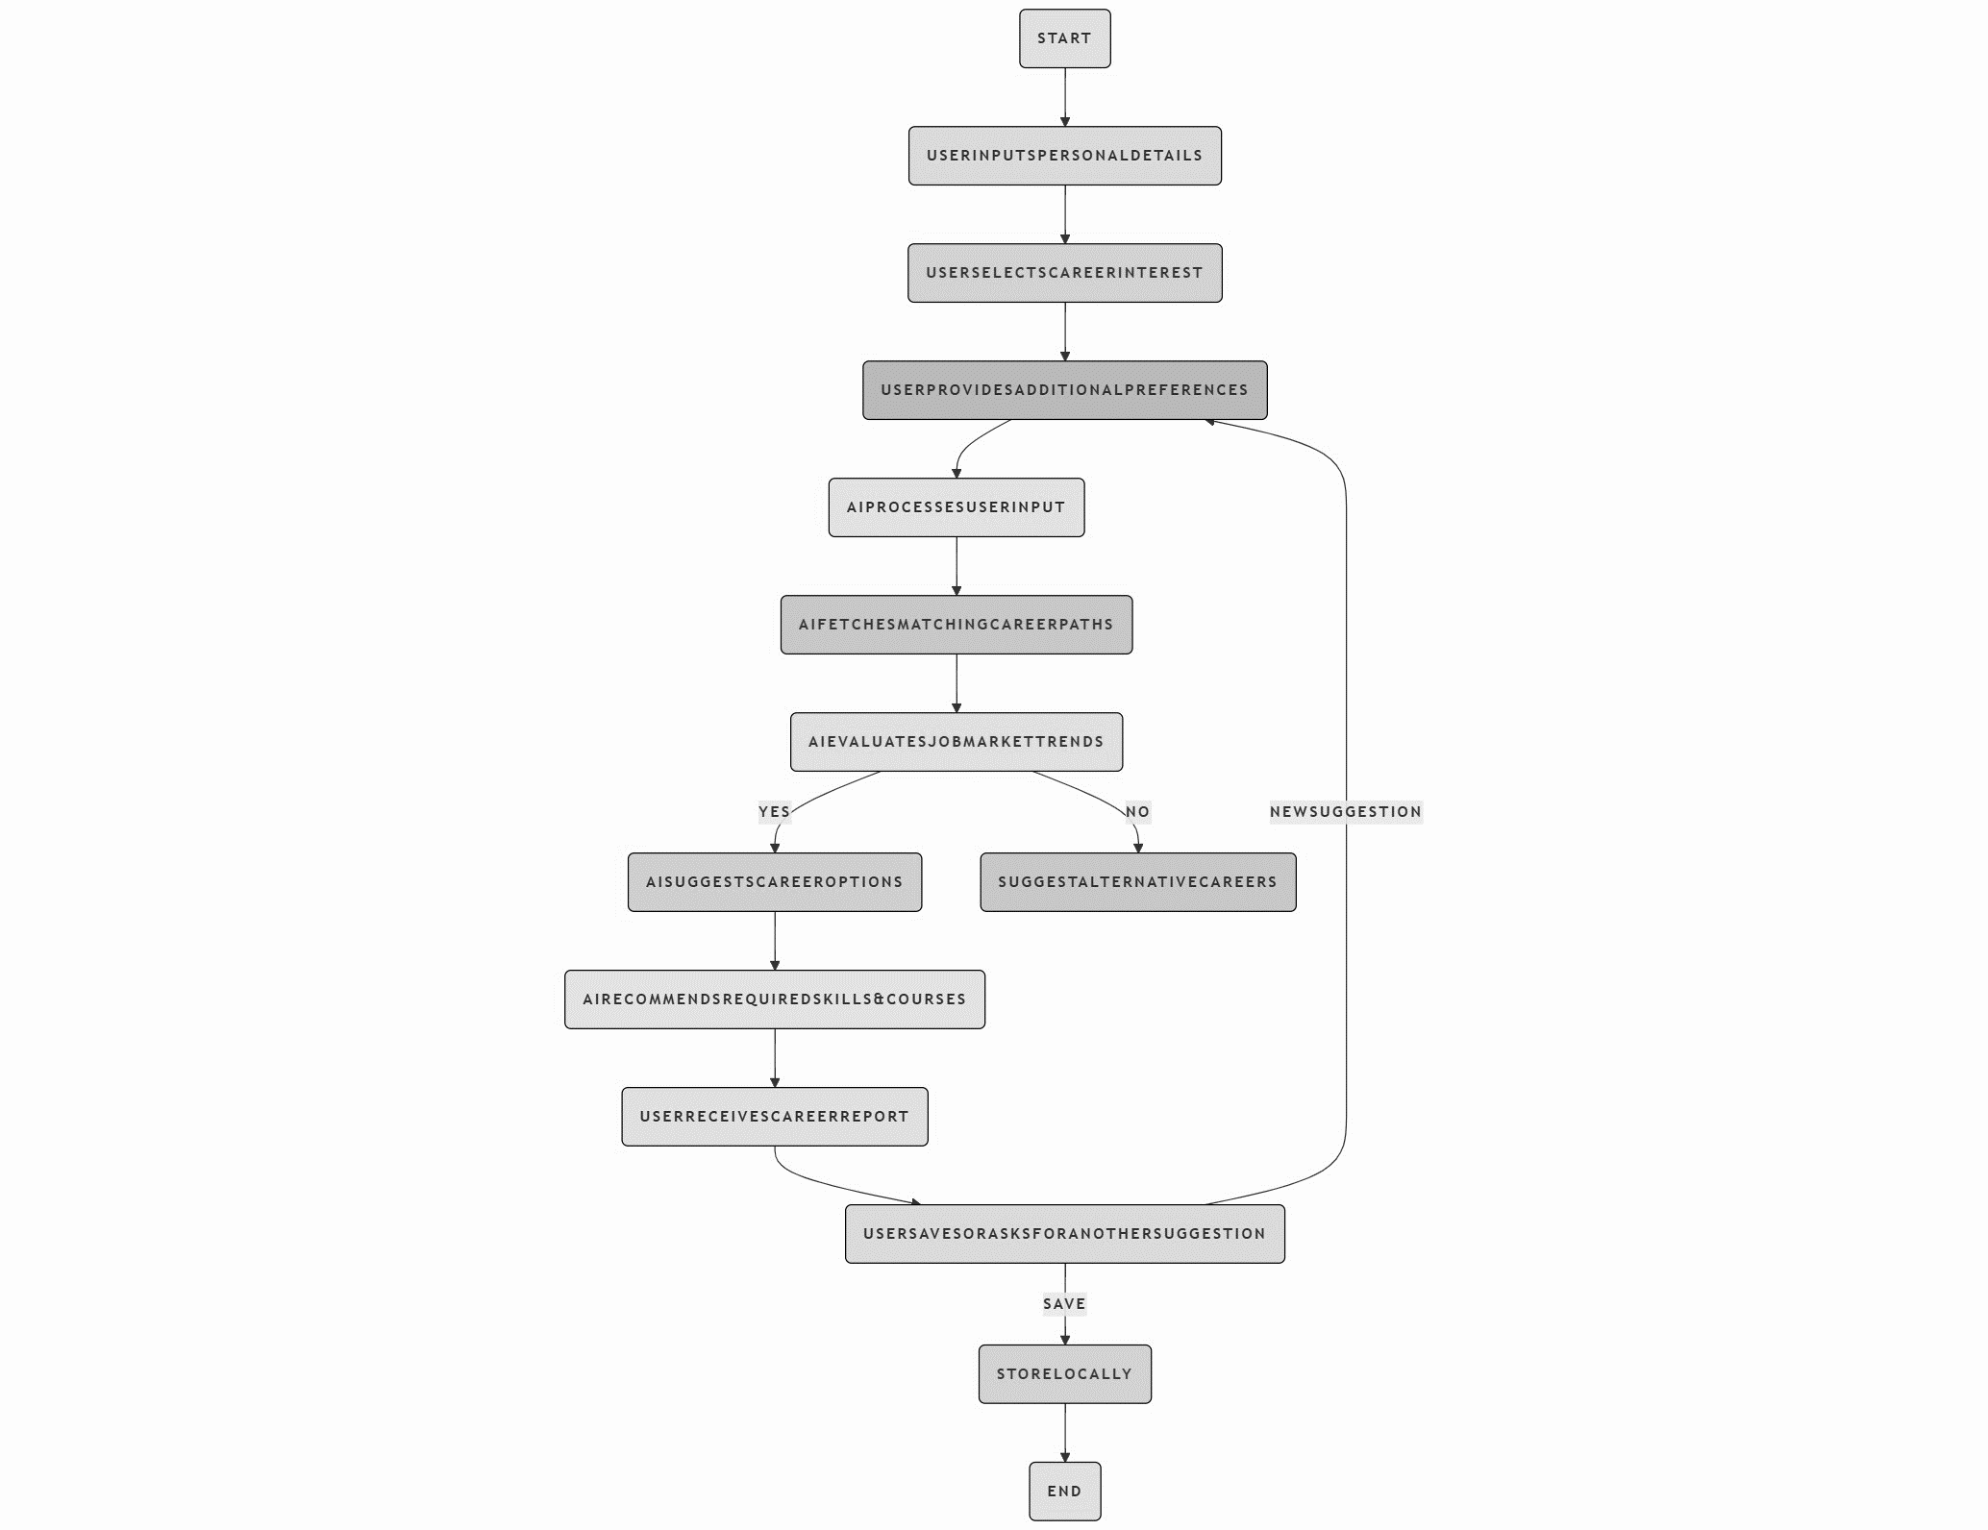

Figure 1.1 : Working of Model

**1.5.1 Requirement Gathering & Research**

Explored how existing systems work (e.g., Coursera career paths, LinkedIn assessments, AI counselors like CareerFitter). Studied APIs (Groq) and technology stacks that can support such a system.

**1.5.2 System Design**

Created mockups and data flow diagrams. Structured frontend components (pages) and backend API routes separately to ensure smooth integration.

**1.5.3 Technology Stack**

Frontend: React JS

Backend: FastAPI

APIs: Groq (chat)

Tools: Visual Studio Code, Swagger UI, Chrome DevTools

**1.5.4 Backend API Creation**

Built three main POST endpoints:

/career/ – Accepts user data and sends it to Groq for processing.

/chat/ – Accepts questions and forwards them to Groq API.

/trends/ – Accepts job search terms and fetches job data from Groq.

/resume-vetter/ – Vets the resume according to the job description

**1.5.5 Frontend Integration**

Each module was connected to the backend using Axios. Responses were rendered interactively using state management (useState) and form handlers (onSubmit, onChange).

**1.5.6 Testing and Deployment**

Swagger UI used for API testing.

Manual testing done for UI responsiveness.

Future-ready structure prepared for production deployment.

* 1. **Tools and Technologies Used**

|  |  |
| --- | --- |
| **Component** | **Tool/Technology Used** |
| Frontend | React JS |
| Backend | Python + FastAPI |
| AI Model | Groq API |
| Chatbot | Groq API |
| Job API | Groq API |
| Resume Vetter | Groq API |
| Testing | Swagger UI, DevTools |
| Hosting | Vercel / Github |

Table 1.1 : Tools and Technologies Used

* 1. **Organization of the Report**

This report is divided into six key chapters:

Chapter 1: Introduction

Introduces the concept, motivation, problem statement, objectives, methodology, and overall structure of the report.

Chapter 2: Review of Literature

Explores past systems and research in AI-driven career advisory systems, chatbots, and job analysis.

Chapter 3: Problem Definition and Objectives

Provides a deeper analytical definition of the problem and articulates the exact goals of the project.

Chapter 4: Design and Implementation

Describes the software design patterns, UI structure, API integration, and actual code-level insights of the system.

Chapter 5: Results and Discussions

Presents outputs, test cases, and discussions around the accuracy, reliability, and limitations of the AI suggestions and modules.

Chapter 6: Conclusion and Future Scope

Summarizes the work, contributions, and outlines future work such as PDF resume integration, psychometric scoring, and recommendation feedback loops.

**Chapter – 2**

**REVIEW OF LITERATURE**

The foundation of any intelligent system, particularly one built on artificial intelligence (AI), lies in the review of previously conducted research and technological advancements. A comprehensive literature review allows the identification of gaps, strengths, and best practices within existing systems. This chapter surveys previous studies, tools, frameworks, and applications developed in the domain of career guidance, resume evaluation, and natural language-based chat assistants. It also provides a detailed account of technologies like large language models (LLMs), resume parsing, AI-based job matching, and the role of APIs in implementing such systems.

**2.1 Evolution of Career Guidance Systems**

The field of career guidance has seen an evolution from conventional in-person counseling to web-based decision-support systems. Early digital systems employed simple rule-based approaches, where predefined logic guided career suggestions based on user inputs such as education, interests, and skills.

Over the years, systems began to incorporate psychometric assessments and interest inventories (e.g., Holland’s RIASEC model) for better personalization. However, these were often rigid, lacked scalability, and couldn’t adapt to dynamic market trends.

Notable Systems:

* Kuder Career Planning System (1995): Used interest inventories but lacked AI-based adaptability.
* CareerScope: Combined assessment results with local labor market trends.
* MyNextMove (US Department of Labor): A public tool that maps interests to occupations but is non-AI.

With the rise of data-driven algorithms, AI became an obvious candidate for transforming the static nature of such systems into something dynamic, learning, and user-centric.

**2.2 AI in Career Guidance**

The application of AI to career advising has become increasingly prevalent due to advancements in machine learning, natural language processing (NLP), and deep learning.

**Key Techniques:**

* **NLP**: Extracts meaning from user input (skills, interests).
* **Clustering**: Groups users by interest/skill similarity.
* **Recommendation Systems**: Suggest careers based on user profiles.
* **Classification**: Matches job roles to user attributes using supervised learning.

Some platforms that have experimented with AI include:

* **PathSource**: Mobile app using user data to match careers.
* **LinkedIn Career Explorer**: Uses job market data to suggest paths.
* **Skillist**: Focuses on skills rather than degrees for better job matching.

While useful, these platforms often depend on proprietary data or limited logic. They lack real-time interaction, multi-modal support (e.g., resume + job description), or comprehensive AI reasoning.

**2.3 Resume Analysis and Vetting Systems**

Resume screening is an integral part of recruitment and career matching. Traditional Applicant Tracking Systems (ATS) screen resumes based on keyword matching and formatting. However, these systems are often rigid and unable to infer deeper compatibility.

Modern systems such as:

* Rezi
* VMock
* JobScan
* Resumatch.io  
  employ AI to vet resumes for quality, relevance, and alignment with job descriptions.

These tools use:

* TextRank and TF-IDF for keyword importance.
* Contextual Embeddings via models like BERT to measure semantic similarity between resumes and job descriptions.
* Score Metrics: Resume quality is often rated on a scale, offering improvement suggestions.

In our system, the Resume Vetter feature builds upon such mechanisms and enhances it by combining resume parsing with AI-based analysis using Groq’s LLM to provide:

1. A resume score.
2. Suggestions to improve.
3. Career match or job fit based on user-provided job descriptions.

**2.4 The Role of AI Chatbots in Career Assistance**

AI chatbots simulate real-time, conversational interaction with users, acting as virtual career advisors. They can answer queries, offer recommendations, and personalize suggestions based on ongoing interaction.

Previous Work Includes:

* ELIZA (1966): The earliest text-based bot mimicking a therapist.
* Replika AI: A general-purpose conversational AI companion.
* Woebot: A CBT-based mental health bot, showcasing AI trustworthiness.

In career services:

* Chatbots are often integrated into university websites or job boards.
* They use intent recognition to understand questions and entity extraction to grasp user context.
* Integration with APIs or databases allows dynamic responses (e.g., fetching job listings, company info).

Our system uses Groq’s LLM, offering a superior chat experience due to the low-latency, high-speed inference of models like llama3-70b-8192. This allows students to ask open-ended queries and receive instant, contextually relevant answers.

**2.5 Large Language Models (LLMs) in Education and Career Tech**

Language models such as GPT-3, Gemini, Claude, and Groq’s Mixtral have redefined the AI landscape. These models understand, generate, and reason over human language with remarkable coherence.

Core Advantages in Career Tech:

* Zero-shot prompting: No need for training on every query.
* Multi-turn conversation: Maintains context across user inputs.
* Personalized guidance: Adjusts tone, depth, and examples based on user type.

Groq’s model stands out due to:

* Fastest LLM inference (sub-200 ms).
* OpenAI-compatible endpoints.
* Access to open models like LLaMA-2, Mistral.

Our project utilizes Groq for:

* Career Q&A.
* Resume improvement.
* Career path generation.

**2.6 Importance of Real-Time Job Trend Analysis**

Job market trends constantly evolve, and static career suggestions become obsolete quickly. By using real-time job APIs like Adzuna or LinkedIn API, platforms can:

* Suggest trending roles.
* Map market demand to user skills.
* Recommend learning paths based on job market gaps.

Although our system no longer uses Adzuna, its principle is replicated using Groq by dynamically generating responses based on:

* Sector demand (IT, Finance, Design).
* Region-specific trends (India, USA, UK).
* Qualification gaps in candidate resumes.

This ensures that the career advice is not only personalized but also market-relevant.

**2.7 Summary of Key Literature Insights**

| **Area** | **Technology/Model** | **Notable Tools** |
| --- | --- | --- |

|  |  |  |
| --- | --- | --- |
| Career Guidance | Rule-based, ML, LLMs | LinkedIn, MyNextMove |

|  |  |  |
| --- | --- | --- |
| Resume Vetting | TF-IDF, BERT, GPT | JobScan, Rezi, Resume Vetter |

|  |  |  |
| --- | --- | --- |
| Chat Assistants | NLP, Transformers | Replika, Woebot, Groq-based |

|  |  |  |
| --- | --- | --- |
| Market Trends | APIs, Embeddings | Adzuna, LinkedIn, Google Trends |

Table 2.1 : Literature Insights

**2.8 Summary**

The literature demonstrates the increasing convergence of AI technologies with career planning, recruitment, and educational guidance. While legacy systems relied heavily on static logic and limited adaptability, the new generation of AI-enabled systems leverages dynamic data, real-time interaction, and context-aware recommendations.

Our project—Virtual AI Career Advisor—builds upon these advancements and combines the best of chat interfaces, LLM capabilities, and document analysis to offer an all-in-one solution for students, job seekers, and professionals.

**Chapter – 3**

**PROBLEM DEFINITION AND OBJECTIVES**

Career choices play a crucial role in defining a person's path, both on a personal and professional level. Nevertheless, the present job market is incredibly dynamic, competitive, and intricate. With a growing range of roles, sectors, and interdisciplinary skills, many students and professionals often feel overwhelmed by the extensive options available. Traditional career counseling techniques, which usually have a limited scope and depend significantly on human expertise, struggle to meet the varied, scalable, and current requirements of a wide audience.

The rise of Artificial Intelligence (AI) has revolutionized many sectors, such as healthcare, education, finance, and now, career counseling. Specifically, Large Language Models (LLMs) like Groq can replicate intelligent decision-making, comprehend human inquiries in context, and provide tailored suggestions.

**3.1 The Problem Space**

**3.1.1 The Disconnect Between Education and Employment**

Recent surveys indicate a disturbing disconnect between the education system and the job market. Graduates are often unaware of the skills needed for their desired industries. The traditional “one-size-fits-all” career paths suggested by counselors no longer align with the diverse and evolving skill sets and interests of individuals.

According to India Skills Report (2024), only 46.2% of graduates are considered employable due to lack of industry-relevant skills.

**3.1.2 Limited Access to Personalized Counseling**

Many institutions lack the infrastructure or trained professionals to offer personalized guidance. Manual career counseling is time-consuming, expensive, and often outdated. In rural or

underdeveloped regions, career counseling remains inaccessible or generic.

**3.1.3 Inadequate Resume and Skill Analysis**

Job seekers often submit resumes that are either outdated or not tailored to specific job descriptions. Most lack the tools or insights to evaluate their own resumes critically. Moreover, they remain unaware of skill gaps until faced with repeated rejections.

**3.1.4 Confusing Job Market Trends**

The job market evolves rapidly. What is trending today might become obsolete tomorrow. For example, roles in blockchain development were barely recognized in 2015, but are now high-demand roles. Without real-time trend analysis, users may pursue declining fields.

**3.2 Existing Solutions and Their Shortcomings**

**3.2.1 Manual Counseling**

* **Strengths**: Human empathy, personal understanding.
* **Weaknesses**: Not scalable, depends on counselor's skill, time-intensive, expensive.

**3.2.2 Online Psychometric Tools**

* **Strengths**: Scalable, automated.
* **Weaknesses**: Generic results, no context-aware suggestions, no job market integration.

**3.2.3 Resume Builders**

* **Strengths**: Simplify resume formatting.
* **Weaknesses**: Do not offer resume vetting or scoring; lack AI-driven matching with job descriptions.

**3.2.4 Career Portals (e.g., LinkedIn, Indeed)**

* **Strengths**: Real-time job listings.
* **Weaknesses**: Do not offer career guidance, no personalized career path suggestions.

**3.3 Statement of the Problem**

In the current digital landscape, where there is a constant influx of information and ever-changing industry dynamics, students and job seekers encounter significant difficulties in selecting the appropriate career path. Conventional career guidance methods tend to be generic, outdated, or inaccessible to many people. A majority of students depend on advice from parents, peer influence, or societal trends rather than making choices grounded in a scientific assessment of their skills, interests, and market demands. This commonly results in dissatisfaction, unsuitable job placements, and the underutilization of individual potential.

Despite the availability of job portals, resume builders, and psychometric evaluations, there is no comprehensive solution that effectively and intelligently assists a user throughout all phases of career development—from self-exploration and career alignment, to resume assessment and live Q&A counseling. These systems operate independently and fail to offer personalized, real-time guidance that adjusts to the user’s profile and the latest market conditions.

The issue is further exacerbated by existing systems' inability to incorporate emerging technologies like Large Language Models (LLMs) in a productive and tailored manner. Traditional systems are often rule-based and restricted to static databases, whereas the modern labor market necessitates adaptive, AI-driven support systems capable of simulating human-like reasoning, interpreting open-ended inputs, and providing contextual recommendations.

The primary issue that this project aims to solve is the absence of a scalable, intelligent, and interactive career guidance system that can:

* Comprehend a wide range of user backgrounds.
* Holistically analyze user data (including resumes and preferences).
* Forecast relevant career pathways with justification
* Assess user skills and resume alignment with job criteria.
* Answer natural-language career inquiries in real-time.

Thus, the fundamental problem statement can be phrased as:

“To create an AI-driven, integrated platform that provides customized career advice, intelligent resume assessment, real-time insights into the job market, and interactive Q&A support by harnessing the power of a Large Language Model (Groq API).”

**3.4 Purpose of the Study**

The main purpose of this study is to conceptualize, design, and implement a virtual AI-powered system that acts as a digital career counselor. The platform aims to guide students, graduates, and professionals by simulating human expertise through AI. It enables users to identify optimal career paths based on their academic backgrounds, skill sets, personality traits, work preferences, and market demands.

By leveraging LLMs like Groq, this study intends to bridge the accessibility and quality gaps in career counseling. The system is expected to provide responses in real-time, allowing users to engage in meaningful conversations about their aspirations, doubts, and next steps. Unlike static web forms or recommendation checklists, the proposed system aims to mimic the dynamic interaction and adaptability of a human counselor.

Another critical aspect of this study is the inclusion of resume analysis and job relevance scoring. This feature allows users to upload their resumes in PDF format and have them evaluated against target job descriptions. The system then generates an AI-powered score along with feedback on missing or weak areas.

The third core purpose is to provide up-to-date job market trends—a necessity in a rapidly changing global economy. AI is used to analyze massive datasets to extract insights about the most in-demand job roles, growing industries, and expected skill shortages, thereby guiding users not only based on what they are but also where the world is heading.

The system is further enhanced with a soft skill and learning path recommender, which proposes relevant courses, certifications, and behavioral adjustments the user may need to become a better fit for their target career.

In summary, the objectives of this study are:

* To create a centralized AI system that integrates all major elements of career guidance.
* To provide real-time, intelligent conversations for personalized career advice using Groq API.
* To enable resume vetting with scoring and feedback generation based on AI interpretation.
* To incorporate job market intelligence and ensure relevance in career suggestions.

**3.5 Project Objectives**

1. Customized Career Suggestions
2. Resume Analysis and Assessment
3. Dynamic Career Q&A Assistant
4. Job Market Trend Analysis
5. Comprehensive Career Development Planning

**3.6 Significance of the Study**

The significance of the Virtual AI Career Advisor is substantial given the changing global employment environment. As automation, artificial intelligence, and globalization continue to reshape various industries, the requirement for career planning resources extends to professionals of all ages. Traditional career counseling approaches, which predominantly rely on manual efforts and are inconsistent, fail to adequately meet the needs of the countless individuals seeking personalized career guidance. This research project is particularly important as it introduces a scalable, AI-based solution to this worldwide challenge.

By employing advanced language models like Groq, the system delivers contextual comprehension, human-like reasoning abilities, and comprehensive analysis, effectively narrowing the gap between conventional approaches and contemporary needs. The aim of the proposed system is to offer accessible, cost-effective, and intelligent career guidance. It eliminates geographical limitations and provides high-quality support to individuals in rural and underprivileged areas who may not have access to career professionals or coaching.

A fundamental aspect of this study is its potential to boost users' self-awareness by assisting them in comprehending how their unique traits (including abilities, preferred learning methods, and interests) relate to the job market. It promotes self-directed career decision-making and eased transitions, cultivating an attitude of continuous learning and adaptability—characteristics that are essential in today’s employment landscape. A core component of this research is its capacity to enhance users' self-awareness by guiding them in identifying how their individual characteristics (such as competencies, learning preferences, and interests) link to the job market. It fosters independent career decisions and supported transitions, encouraging a culture of lifelong education and flexibility—traits that are vital in the modern job environment.

As a result, this research contributes significantly to:

* Improving digital literacy and self-assurance among job seekers.
* Encouraging fair access to career counseling.
* Addressing the skills-job mismatch through tailored recommendations.
* Incorporating LLM-driven intelligence into personal growth and employment strategies.

**3.7 Scope of the Project**

The scope of the Virtual AI Career Advisor spans multiple facets of career development and job readiness, making it a comprehensive system for both students and working professionals. Below is a detailed look at the coverage:

Included Scope:

* Career Recommendation Engine: Using user attributes to suggest relevant professions.
* Resume Vetter (Resume-Vetter): PDF upload and analysis against job descriptions, providing a match score and enhancement tips.
* LLM-Powered Chatbot: Career-related queries answered in a conversational, intelligent manner.
* Job Trends Forecasting: Highlights trending industries, popular job roles, and future skills.
* Soft Skill and Course Recommendation: Suggests soft skills and online courses aligned with target career.
* Session-Based Personalization: Remembers user sessions for ongoing personalized advice.

Technical Scope:

* Frontend: React.js for all user-facing functionalities and forms.
* Backend: FastAPI-based Python server for handling logic, APIs, and integrations.
* LLM Integration: Groq API used across modules (recommendation, chat, vetting).
* No Database: This project functions in a stateless mode for now; persistence is not implemented, but may be in future iterations.

Limitations / Out of Scope:

* Does not support voice interactions (text-only).
* Cannot perform real-time interview scheduling or company outreach.
* Job trend data is limited to what Groq API can infer; no live scraping of job portals.
* Privacy protection mechanisms are basic, given the absence of user accounts.

This defined scope ensures the system remains focused on solving specific, meaningful problems while keeping the implementation manageable and modular.

**3.8 Assumptions and Constraints**

Every system is built on certain assumptions and operates within real-world constraints. For this project, the following were assumed during design and implementation:

Assumptions:

1. Users have internet access and basic digital literacy to interact with a web application.
2. Groq API remains accessible and free during the development and deployment lifecycle.
3. Resume files are provided in readable PDF format, not scanned or image-based PDFs.
4. Users will provide honest and descriptive answers in career forms.
5. Frontend and backend are hosted locally during development, assumed to be on the same machine or accessible via localhost.

Constraints:

* API Rate Limits: Groq may have usage limits, affecting scalability.
* Stateless Architecture: Without a database, user sessions and history are not stored.
* No NLP Preprocessing: Resume and JD text are sent raw to LLM without fine-tuning or semantic embeddings.
* Frontend-Only File Uploads: Resume uploads are handled by the frontend and passed directly to the backend without cloud storage.
* Cost and Resources: Project uses free APIs, hence scalability and response reliability are dependent on external services.

These assumptions and constraints were carefully considered during planning and affect both the functional and non-functional behavior of the application.

**3.9 Summary of Objectives**

|  |  |
| --- | --- |
| **Objective** | **Description** |
| Personalized Advice | Offer career paths tailored to user's inputs using Groq API |
| Resume Scoring | Provide quantitative feedback on resume quality |
| Skill Gap Identification | Suggest specific skills the user lacks |
| Career Q&A Assistant | Allow dynamic, contextual conversations |
| Future Trends Forecasting | Recommend roles based on job market trends |

Table 3.1 : Objectives

**Chapter – 4**

**DESIGN AND IMPLEMENTATION**

**4.1 System Architecture Overview**

The architecture of the Virtual AI Career Advisor system is designed using a modular and layered approach, enabling scalability, maintainability, and ease of integration with APIs like Groq. The overall architecture follows a client-server model, where the client (frontend) interacts with the server (backend) via HTTP requests.

At the core, the system consists of four major modules: Career Recommendation, Resume Vetter, Interactive Q&A Chatbot, and Job Market Trends. These modules are encapsulated into individual services that communicate with a centralized backend powered by FastAPI, a high-performance web framework for building APIs with Python.

The system utilizes Groq API exclusively for all intelligent decision-making functionalities including natural language processing, career suggestions, chatbot responses, and resume analysis.

The major components of the architecture include:

* Frontend Layer (React.js): Manages the user interface and form data, ensures interactive experiences, handles validations, and displays API responses.
* Backend Layer (FastAPI): Manages API routes, request parsing, response formation, and external API calls (like Groq).
* AI Layer (Groq API): Powers all intelligence in the system — from generating career paths to vetting resumes and replying to chat messages.
* Storage Layer (Temporary Runtime Storage): Since no database is used, data is only held during runtime for processing requests.

The following is a simplified architecture flow:

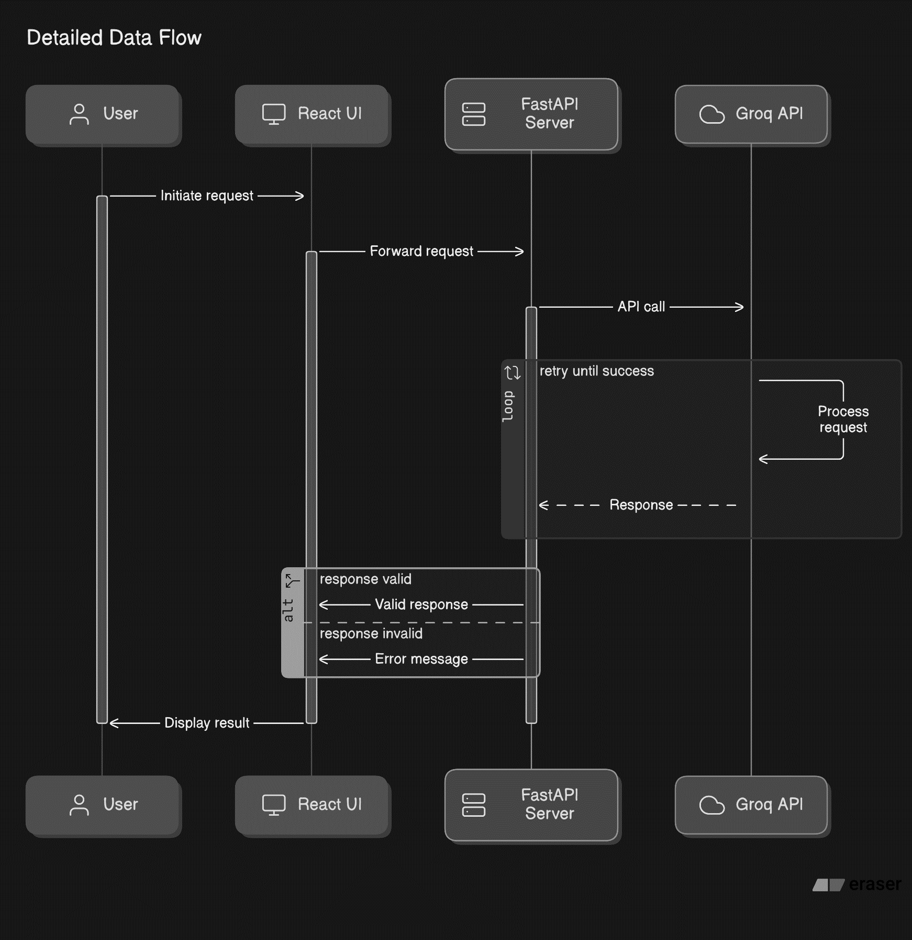

Figure 4.1 : Data Flow Diagram

This layered approach ensures clear separation of concerns and allows each module to evolve independently without affecting the rest of the system.

**4.2 Technology Stack**

To build the Virtual AI Career Advisor, we utilized a set of modern and widely adopted technologies. Each component of the stack was carefully chosen based on performance, ease of use, community support, and compatibility with AI APIs.

**4.2.1 Frontend Technologies:**

* React.js: JavaScript library used for building interactive and responsive user interfaces.
* HTML5 & CSS3: Markup and styling of the frontend interface.
* Axios: Used to make HTTP requests from the frontend to the backend.

**4.2.2 Backend Technologies:**

* Python 3.10+: Chosen for its rich ecosystem and ease of integration with AI APIs.
* FastAPI: A modern, asynchronous web framework used for defining API endpoints with high performance.
* Uvicorn: ASGI server used to run the FastAPI app in development.

**4.2.3 AI/ML Integration:**

* Groq API: A powerful LLM (Large Language Model) API used to handle:
  + Career recommendation reasoning
  + Resume vetting and analysis
  + Chatbot response generation
  + Contextual decision making based on prompts

**4.2.4 Supporting Tools & Packages:**

* pydantic: Used for data validation and parsing of request models.
* requests: Python library used to make external HTTP requests to the Groq API.
* PyPDF2: For extracting text from uploaded resumes (PDF files).

**4.2.5 Development Tools:**

* Visual Studio Code (VS Code): Main IDE used for coding both frontend and backend.
* Swagger UI: Used for testing the backend endpoints.
* Git: Version control system used for tracking project changes.

This technology stack provides a seamless bridge between the UI and AI logic, ensuring fast responses and maintainable codebases. All tools are open-source or freely available for development purposes, keeping costs minimal while delivering a highly functional application.

**4.3 Functional Modules**

The Virtual AI Career Advisor is designed with a modular approach. Each module handles a specific functionality of the system. Below is an in-depth explanation of all key modules:

**4.3.1 Career Recommendation Module**

This is the core feature of the system. Users provide personal and professional details such as age group, qualification, skills, interests, work style, experience, and more. These inputs are compiled into a structured prompt and sent to the Groq API, which uses a large language model (LLM) to analyze the data and return personalized career suggestions with logical reasoning. The recommendation is based on skill alignment, industry trends, and individual preferences.

**4.3.2 Resume Vetter Module**

This module allows users to upload their resumes and optionally paste job descriptions. Using Groq’s language model, the system parses the resume content, compares it to the provided job description, and returns:

* A resume score out of 100
* A match percentage
* Highlighted skills gap
* Suggested improvements

PDF files are extracted using a library like PyPDF2 and then passed to Groq’s model for analysis.

**4.3.3 Interactive Q&A Chatbot**

The chatbot enables real-time interaction with users. Users can type any career-related query — such as guidance for exams, best countries to work in, skill development tips, etc. The chat messages are forwarded to Groq API with a system prompt defining the AI's role as a career advisor. The API returns context-aware, intelligent responses.

**4.3.4 Job Trends Module**

This module analyzes the job market and provides trending job titles, career domains, and in-demand skills. Instead of relying on third-party data from sites like Adzuna or LinkedIn (due to API limitations), the trends are queried directly from the Groq LLM based on input keywords like job category or country. This enables flexible and broad analysis without scraping or licensing issues.

Each of these modules works independently and communicates via the FastAPI backend.

**4.4 Data Flow Diagram (DFD)**

To visualize the movement of data across the system, the following levels of **Data Flow Diagrams** (DFD) can be presented:

**4.4.1 Level 0 DFD (Context-Level)**

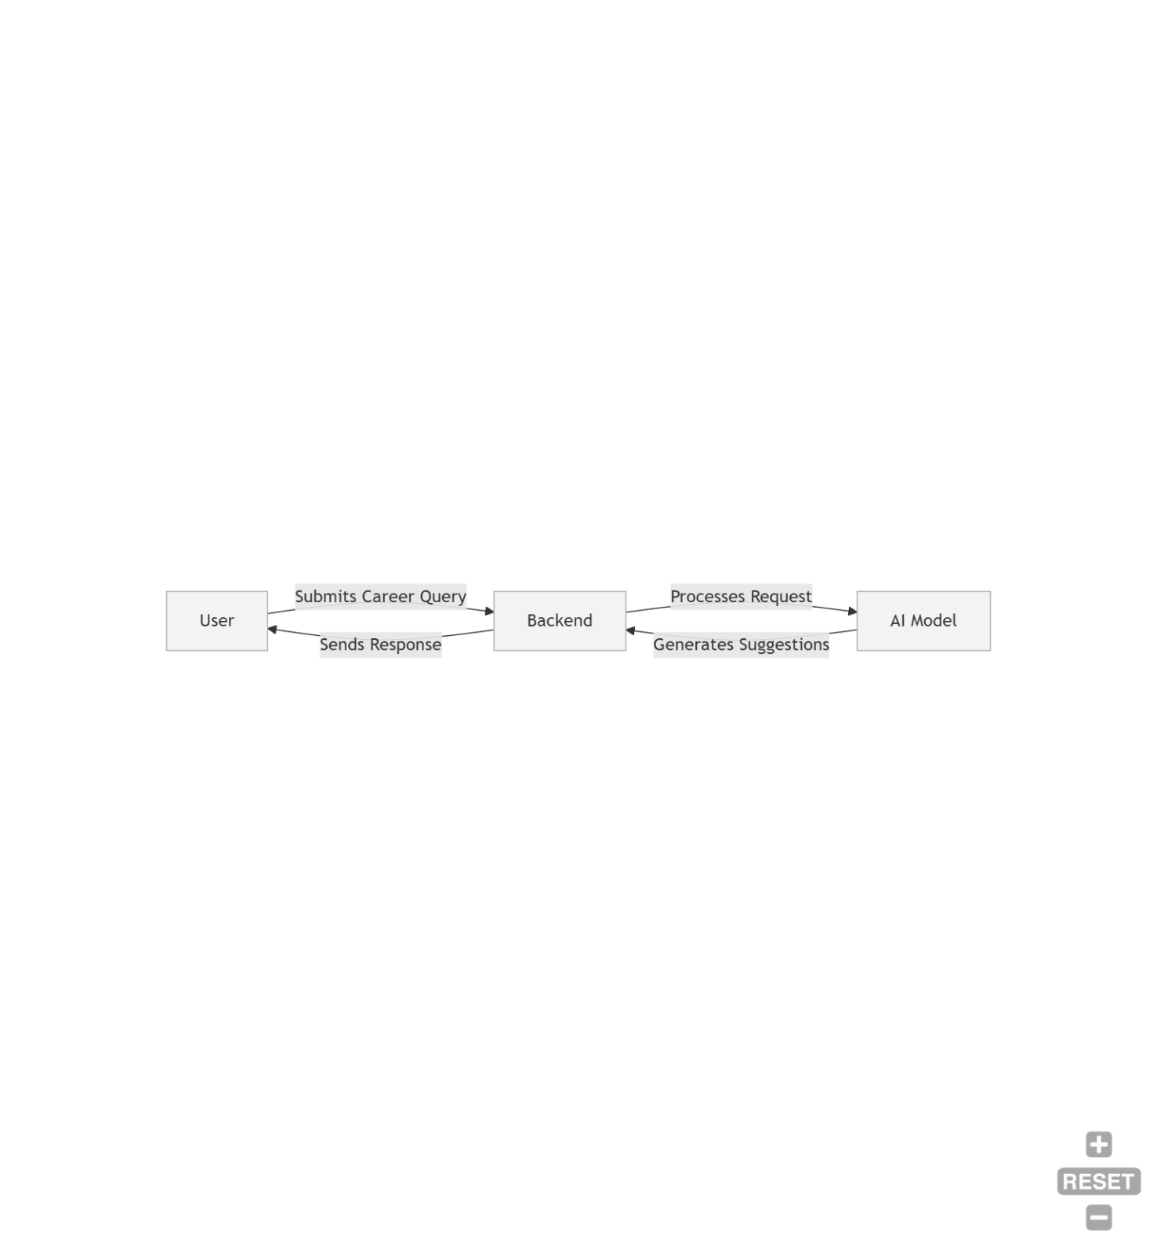

Figure 4.2 : Level 0 DFD

At the top level, the system is represented as a black box featuring essential interactions:

* The user poses a question related to career guidance.
* The backend processes the inquiry and forwards it to the AI model.
* The AI model evaluates the question and produces career suggestions.
* The formatted response is then sent back to the user.

This methodology guarantees that career advice is provided effectively.

**4.4.2 Level 1 DFD (Detailed Process Flow)**

Level 1 DFD elaborates on the main components:

**4.4.2.1. User Interaction**

* The user enters a career-related question via the web interface.
* Input validation checks for mistakes or irrelevant questions.

**4.4.2.2. Processing Layer**

* The backend receives the inquiry and processes it according to established rules.
* The system communicates with the AI API to evaluate the query.

**4.4.2.3. AI-Based Career Analysis**

* The AI model produces career recommendations based on the user's input.
* Additional information, such as skill requirements or job market dynamics, may be included.

**4.4.2.4. Response Handling**

* The processed response is formatted for display.
* The result is presented to the user interactively.

This organized approach guarantees that all inquiries are handled efficiently.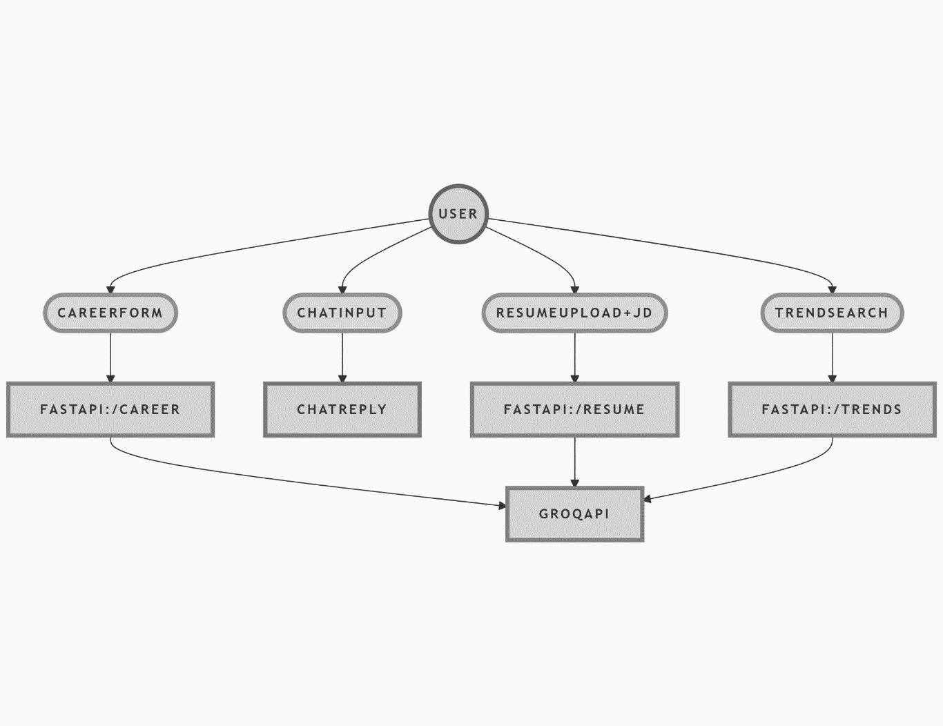

Figure 4.3 : Level 1 DFD

**4.5 User Interface Design**

The frontend of the system is designed using React.js with a focus on clarity, responsiveness, and ease of use. Key principles used in the UI design include:

**4.5.1 Homepage**

* A clean layout with a large motivational quote, logo, and “Get Started” button.
* Responsive design that scales across laptops, tablets, and mobile devices.

**4.5.2 Navigation Bar**

* Visible on all pages after clicking "Get Started."
* Contains links to:
  + Career Recommendation
  + Resume Vetter
  + Job Market Trends
  + Interactive Chat

**4.5.3 Form Layouts**

* Input fields designed with clear labels and spacing.
* White input boxes over a transparent or dark background.
* Uses dropdowns and textboxes to simplify data entry.

**4.5.4 Chat Interface**

* Real-time chat display with distinct message styles for user and bot.
* “Typing...” loader for better experience.
* Input field and send button positioned at the bottom.

**4.5.5 Result Display**

* All responses from Groq are shown in neatly styled boxes.
* Resume score, chatbot replies, and career suggestions appear within their dedicated modules.
* Error messages (e.g., API failures) are displayed in red for clarity.

The design principles ensure that the system remains user-friendly, visually appealing, and functional across all modules. CSS is used to implement custom styling, and every module maintains consistency with the overall theme.

**4.6 System Flowchart**

The system flowchart is a graphical representation of the logical flow of operations in the Virtual AI Career Advisor. It visually maps out how user data is collected, processed through the backend, sent to the Groq API, and how the results are returned and displayed to the user.

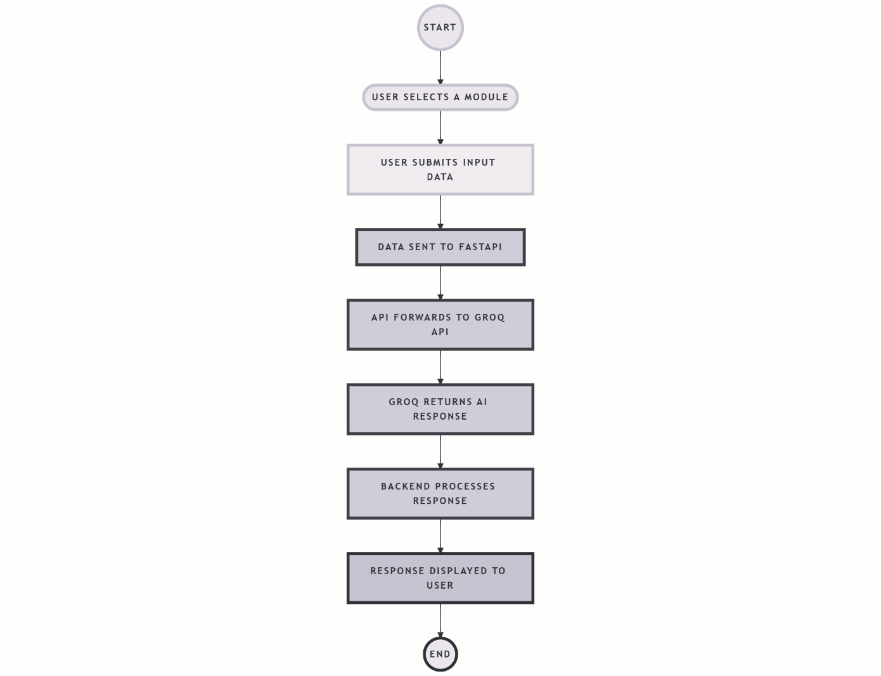

Figure 4.4 : System Flowchart

This flowchart illustrates a modular and repeatable process that is common to all the modules (Career Advisor, Chatbot, Resume Vetter).

**4.7 Use Case Diagram**

The use case diagram outlines how users interact with different parts of the system. There is one main actor — the *User* — who can access all the core modules.

**Actors:**

* **User**: A student, job seeker, or professional using the AI Advisor.

**Use Cases:**

* Submit Career Details
* Upload Resume and Job Description
* Ask Career-Related Questions
* Search for Job Market Trends
* View AI-generated Recommendations

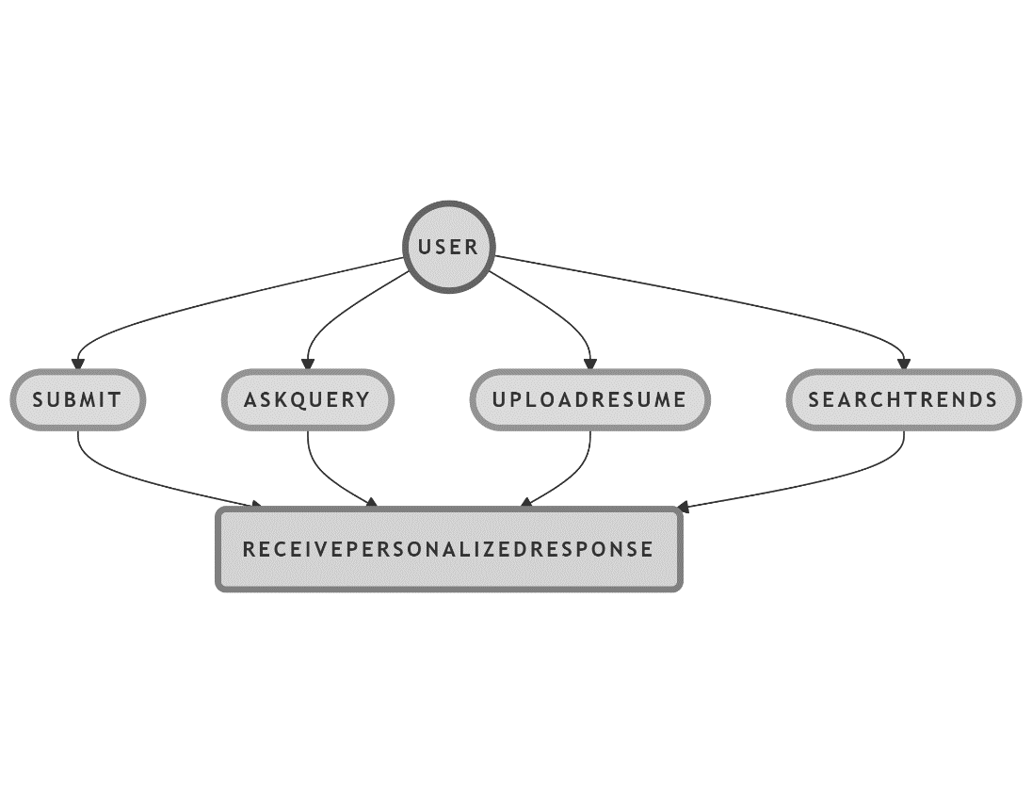

Figure 4.5 : Use Case Diagram

**4.8 Backend Logic and API Integration**

The backend of the *Virtual AI Career Advisor* is built using FastAPI, a modern, fast (high-performance) web framework for building APIs with Python. The backend handles all user inputs, processes them into structured prompts, sends these to the Groq API, and returns the AI-generated responses to the frontend.

**Core API Endpoints**

* **/career/**:
  + Accepts form data related to user's background, skills, and preferences.
  + Constructs a prompt and sends it to Groq API using POST method.
  + Receives a career recommendation and returns it to the frontend.
* **/chat/**:
  + Accepts a single-line message from the user.
  + Sends this as a prompt to Groq, expecting an informative or advisory response.
  + Returns the AI-generated response for display in the chatbot UI.
* **/resume-vetter/**:
  + Accepts a user’s uploaded resume PDF and a job description.
  + Extracts text from PDF using PyMuPDF or pdfplumber.
  + Compares both using Groq’s NLP capabilities to provide:
    - Resume Match Score
    - Keywords Missing
    - Suggestions to improve resume for the job role
* **/jobs/**:
  + Accepts a job keyword and location.
  + For now uses dummy logic or static data but can be connected to job boards via APIs.
  + Returns latest trends or job role suggestions.

**4.9 Technologies Used**

In the development of the Virtual AI Career Advisor, various modern tools and technologies were leveraged for both frontend and backend development to ensure performance, scalability, and user engagement.

**4.9.1 Frontend Technologies**

| **Technology** | **Purpose** |
| --- | --- |
| React.js | To create a component-based, dynamic, and interactive UI |
| JavaScript (ES6+) | For client-side scripting and business logic |
| Axios | To make API calls from the frontend to the backend |
| CSS3 | For styling the layout, buttons, forms, and animations |
| React Router DOM | For seamless single-page routing/navigation between modules |

Table 4.1 : Frontend Technologies

**4.9.2 Backend Technologies**

| **Technology** | **Purpose** |
| --- | --- |
| Python 3.13 | Backend programming language |
| FastAPI | High-performance API framework to expose endpoints for React |
| Uvicorn | ASGI server used to run the FastAPI app |
| Requests | To make outgoing API calls to Groq (AI responses), resume vetting, etc. |
| PyPDF2 | For extracting and analyzing resume content from PDF files |

Table 4.2 : Backend Technologies

**4.9.3 External APIs & Tools**

| **Tool / API** | **Usage** |
| --- | --- |
| Groq API | For AI-based chatbot, career advice, and resume analysis |
| Visual Studio Code | Integrated Development Environment (IDE) for both frontend and backend |
| draw.io | Used for designing flowcharts, system architecture, and UML diagrams |
| Postman / Swagger UI | To test API routes and view FastAPI documentation |
| Git / GitHub | For version control, team collaboration, and code repository management |

Table 4.3 : External APIs & Tools

**4.10 Code Implementation**

**4.10.1 Backend**

* **main.py**

from fastapi import FastAPI, HTTPException

from fastapi.middleware.cors import CORSMiddleware

from pydantic import BaseModel

from typing import Optional

import requests

import os

from dotenv import load_dotenv

from bs4 import BeautifulSoup

import PyPDF2

import io

from typing import Dict, List

import re

from fastapi import FastAPI, HTTPException, UploadFile, File, Form, status

from fastapi.responses import JSONResponse

import json

from datetime import datetime

load_dotenv()

app = FastAPI(

title="AI Career Advisor API",

description="API for career recommendations, chat assistance, and job trends",

version="1.0.0"

)

app.add_middleware(

CORSMiddleware,

allow_origins=["*"],

allow_credentials=True,

allow_methods=["*"],

allow_headers=["*"],

)

class CareerRequest(BaseModel):

name: Optional[str] = None

ageGroup: str

qualification: str

skills: str

interests: str

workStyle: str

experience: str

subjects: Optional[str] = None

hobbies: Optional[str] = None

learningStyle: str

priority: str

personalityType: Optional[str] = None

preferredIndustries: Optional[str] = None

longTermGoal: Optional[str] = None

workingHours: Optional[str] = None

travelWillingness: Optional[str] = None

class ChatRequest(BaseModel):

message: str

model: Optional[str] = "llama3-8b-8192"

class ResumeVettingRequest(BaseModel):

resume_text: Optional[str] = None

resume_pdf: Optional[bytes] = None

job_description: Optional[str] = None

model: Optional[str] = "llama3-70b-8192"

analysis_type: Optional[List[str]] = ["ats", "skills", "structure"]

import PyPDF2

import io

def extract_text_from_pdf(pdf_bytes: bytes) -> str:

"""Extract text content from PDF bytes."""

try:

reader = PyPDF2.PdfReader(io.BytesIO(pdf_bytes))

text = "\n".join([page.extract_text() for page in reader.pages if page.extract_text()])

return text.strip() if text else ""

except Exception as e:

raise HTTPException(

status_code=400,

detail=f"Failed to process PDF: {str(e)}"

)

def handle_api_error(e: Exception, service_name: str) -> None:

"""Handle API errors consistently"""

error_msg = f"{service_name} API Error: {str(e)}"

if isinstance(e, requests.exceptions.RequestException):

error_msg += f" | Status Code: {e.response.status_code if hasattr(e, 'response') else 'Unknown'}"

raise HTTPException(status_code=500, detail=error_msg)

def call_groq_api(prompt: str, model: str = "llama3-8b-8192") -> str:

"""Generic function to call Groq API"""

groq_api_key = os.getenv("GROQ_API_KEY") or "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"

url = "https://api.groq.com/openai/v1/chat/completions"

headers = {

"Authorization": f"Bearer {groq_api_key}",

"Content-Type": "application/json"

}

data = {

"model": model,

"messages": [

{

"role": "system",

"content": "You are a professional career counselor with 20 years of experience."

},

{

"role": "user",

"content": prompt

}

],

"temperature": 0.7,

"max_tokens": 1024,

"top_p": 0.9

}

response = requests.post(url, headers=headers, json=data)

response.raise_for_status()

result = response.json()

return result["choices"][0]["message"]["content"]

@app.post("/chat/", summary="Chat with AI assistant")

async def chat_with_bot(payload: ChatRequest):

"""

Chat with AI assistant about career-related questions.

"""

try:

response = call_groq_api(payload.message, payload.model)

return {

"response": response,

"model": payload.model

}

except Exception as e:

handle_api_error(e, "Groq Chat")

@app.post("/career/", summary="Get career recommendations")

async def recommend_career(

resume_pdf: UploadFile = File(None),

name: str = Form(None),

ageGroup: str = Form(None),

qualification: str = Form(None),

skills: str = Form(None),

interests: str = Form(None),

workStyle: str = Form(None),

experience: str = Form(None),

subjects: str = Form(None),

hobbies: str = Form(None),

learningStyle: str = Form(None),

priority: str = Form(None),

personalityType: str = Form(None),

preferredIndustries: str = Form(None),

longTermGoal: str = Form(None),

workingHours: str = Form(None),

travelWillingness: str = Form(None)

):

"""

Get personalized career recommendations based on either:

- Uploaded resume PDF, or

- Detailed form fields, or

- Combination of both

"""

try:

extracted_info = ""

if resume_pdf:

if resume_pdf.content_type != "application/pdf":

return JSONResponse(

status_code=status.HTTP_400_BAD_REQUEST,

content={"detail": "Only PDF files are allowed"}

)

pdf_bytes = await resume_pdf.read()

extracted_info = extract_text_from_pdf(pdf_bytes)

form_fields = {

"name": name,

"ageGroup": ageGroup,

"qualification": qualification,

"skills": skills,

"interests": interests,

"workStyle": workStyle,

"experience": experience,

"subjects": subjects,

"hobbies": hobbies,

"learningStyle": learningStyle,

"priority": priority,

"personalityType": personalityType,

"preferredIndustries": preferredIndustries,

"longTermGoal": longTermGoal,

"workingHours": workingHours,

"travelWillingness": travelWillingness

}

prompt = f"""Analyze this career profile and provide detailed recommendations:

### Extracted from Resume:

{extracted_info[:10000] if extracted_info else "No resume provided"}

### Provided Information:

{json.dumps({k: v or "Not provided" for k, v in form_fields.items()}, indent=2)}

### Instructions:

1. First extract key information from the resume if provided

2. Combine with explicitly provided information

3. Provide 3 detailed career recommendations with:

- Career title

- Why it's a good fit

- Required qualifications/skills

- Growth potential

- Salary expectations

- First steps to pursue

4. Format with clear headings and bullet points

5. Highlight which information came from resume vs form

"""

recommendations = call_groq_api(prompt, "llama3-70b-8192")

return JSONResponse(

status_code=status.HTTP_200_OK,

content={

"status": "success",

"recommendations": recommendations,

"source": "PDF + Form Fields" if extracted_info else "Form Fields Only"

}

)

except Exception as e:

print(f"Career recommendation error: {str(e)}")

return JSONResponse(

status_code=status.HTTP_500_INTERNAL_SERVER_ERROR,

content={

"status": "error",

"detail": f"Career analysis failed: {str(e)}",

"suggestion": "Try providing more information or a different resume"

}

)

@app.get("/jobs/")

async def groq_job_search(query: str = "software engineer", location: str = "remote"):

"""

Get AI-generated job market insights using only Groq

Example: /jobs/?query=python&location=india

"""

try:

prompt = f"""

Act as a senior career advisor with access to global job market data.

Provide detailed insights about {query} jobs in {location} including:

1. Current market demand (High/Medium/Low)

2. Typical salary ranges

3. Top companies hiring for these roles

4. Required skills/qualifications

5. 5 specific job recommendations with:

- Hypothetical job titles

- Company names

- Key requirements

- Growth potential

- Recommended application strategy

Format the response with clear sections and bullet points.

Include realistic but generic examples since we're not connecting to actual job boards.

"""

recommendations = call_groq_api(prompt)

return {

"source": "AI-generated market analysis",

"query": query,

"location": location,

"analysis": recommendations,

"note": "These are AI-generated insights based on general market knowledge"

}

except Exception as e:

handle_api_error(e, "Groq Job Search")

@app.post("/vet-resume/")

async def vet_resume(

resume_pdf: UploadFile = File(None),

resume_text: str = Form(None),

job_description: str = Form(None),

analysis_type: List[str] = Form(["ats", "skills", "structure"]),

nocache: str = Form(None)

):

try:

resume_content = resume_text or ""

if resume_pdf:

if resume_pdf.content_type != "application/pdf":

return JSONResponse(

status_code=status.HTTP_400_BAD_REQUEST,

content={"detail": "Only PDF files are allowed"}

)

pdf_bytes = await resume_pdf.read()

resume_content = extract_text_from_pdf(pdf_bytes)

if not resume_content.strip():

return JSONResponse(

status_code=status.HTTP_400_BAD_REQUEST,

content={"detail": "No resume content provided"}

)

prompt = f"""Analyze this resume for a {job_description or 'general'} position.

Current date: {datetime.now().strftime("%Y-%m-%d")}

Analysis ID: {nocache or "1"}

Return ONLY valid JSON with these exact fields:

{{

"overall_score": (0-100, calculated based on content),

"ats_score": (0-100, ATS compatibility),

"skill_score": (0-100, skill match),

"structure_score": (0-100, organization),

"detailed_feedback": (markdown string),

"missing_skills": [array of strings],

"suggested_improvements": [array of strings]

}}

RESUME CONTENT:

{resume_content[:15000]}

JOB DESCRIPTION:

{job_description or 'Not provided'}

IMPORTANT:

- Calculate fresh scores each time

- Never return placeholder/default values

- Ensure all scores are between 0-100

- JSON must be parseable

"""

max_retries = 2

for attempt in range(max_retries):

try:

groq_response = call_groq_api(prompt, "llama3-70b-8192")

json_str = groq_response[groq_response.find('{'):groq_response.rfind('}')+1]

analysis = json.loads(json_str)

required_fields = ['overall_score', 'ats_score', 'skill_score']

for field in required_fields:

if field not in analysis or not isinstance(analysis[field], int) or not 0 <= analysis[field] <= 100:

raise ValueError(f"Invalid {field} value")

break

except (json.JSONDecodeError, ValueError) as e:

if attempt == max_retries - 1:

print(f"Groq response parsing failed: {str(e)}")

print(f"Raw response: {groq_response}")

raise

continue

return JSONResponse(

status_code=status.HTTP_200_OK,

content={

"status": "success",

"data": {

"overall_score": analysis["overall_score"],

"ats_score": analysis["ats_score"],

"skill_score": analysis["skill_score"],

"structure_score": analysis.get("structure_score", 0),

"detailed_feedback": analysis["detailed_feedback"],

"missing_skills": analysis["missing_skills"],

"suggested_improvements": analysis["suggested_improvements"],

"analysis_id": nocache

}

}

)

except Exception as e:

print(f"Error in vet_resume: {str(e)}")

return JSONResponse(

status_code=status.HTTP_500_INTERNAL_SERVER_ERROR,

content={

"status": "error",

"detail": f"Analysis failed: {str(e)}",

"retry_suggestion": "Please try again with a slightly modified resume text"

}

)

@app.get("/health")

async def health_check():

return {"status": "healthy", "version": app.version}

**4.10.2 Frontend**

* **Home.js**

import React from "react";

import { Link } from "react-router-dom";

import "./Home.css";

import logo from '../assets/logo.png';

import backgroundImage from '../assets/ai-background.png';

const Home = () => {

return (

<div

className="home-container"

style={{

backgroundImage: `url(${backgroundImage})`,

backgroundSize: "cover",

backgroundPosition: "center",

minHeight: "100vh",

}}

>

<img src={logo} alt="Career Advisor Logo" className="logo" />

<div className="content">

<p className="quote">

🌍 Studies show that over 70% of people work in careers that don’t match their skills or interests.

For instance, in India, only 8.25% of graduates are employed in roles that align with their qualifications.

This highlights a significant mismatch in the workforce, with many individuals underemployed or working in positions that don't utilize their full potential.

Finding the right career can boost job satisfaction, productivity, and success.

Why settle for less when you can find your perfect path?

</p>

<h1 className="headline">Let’s Choose the Best Career Path 🚀</h1>

<Link to="/recommendation">

<button className="start-button">Get Started</button>

</Link>

</div>

</div>

);

};

export default Home;

* **Home.css**

.home-container {

background-image: url('../assets/ai-background.png');

background-size: cover;

background-position: center;

min-height: 100vh;

width: 100%;

color: white;

display: flex;

flex-direction: column;

align-items: center;

justify-content: center;

position: relative;

padding: 2rem;

text-align: center;

box-sizing: border-box;

}

.logo {

position: absolute;

top: 10px;

left: 10px;

width: 130px;

height: auto;

z-index: 10;

}

.content {

max-width: 90%;

margin-top: 3rem;

}

.quote {

font-size: 1.8rem;

font-weight: 400;

margin-bottom: 2rem;

line-height: 1.8;

text-shadow: 1px 1px 2px rgba(0,0,0,0.6);

}

.headline {

font-size: 2.5rem;

font-weight: 600;

margin-bottom: 2rem;

}

.start-button {

padding: 2rem 3rem;

font-size: 2rem;

font-weight: bold;

background-color: #00cc66;

color: white;

border: none;

border-radius: 8px;

cursor: pointer;

transition: background 0.3s ease;

}

.start-button:hover {

background-color: #00b359;

}

@media (max-width: 768px) {

.logo {

width: 100px;

top: 5px;

left: 5px;

}

.quote {

font-size: 1rem;

}

.headline {

font-size: 1.5rem;

}

.start-button {

width: 80%;

font-size: 1rem;

padding: 0.8rem;

}

}

* **Layout.js**

import React from 'react';

import { Outlet, Link, useLocation } from 'react-router-dom';

import './Layout.css';

import logo from '../assets/logo.png';

import backgroundImage from '../assets/ai-background.png';

const Layout = () => {

const location = useLocation();

const isActive = (path) => location.pathname === path ? 'active' : '';

return (

<div

className="layout-container"

style={{

backgroundImage: `url(${backgroundImage})`,

backgroundSize: 'cover',

backgroundPosition: 'center',

backgroundAttachment: 'fixed',

minHeight: '100vh'

}}

>

{}

<div className="content-overlay"></div>

<header className="layout-header">

<div className="header-content">

<Link to="/" className="logo-link">

<img

src={logo}

alt="CareerAI Logo"

className="layout-logo"

/>

</Link>

<nav className="layout-nav">

<ul>

<li>

<Link

to="/recommendation/"

className={`nav-link ${isActive('/recommendation/')}`}

>

Career Recommendations

</Link>

</li>

<li>

<Link

to="/jobs/"

className={`nav-link ${isActive('/jobs/')}`}

>

Job Trends

</Link>

</li>

<li>

<Link

to="/chat/"

className={`nav-link ${isActive('/chat/')}`}

>

AI Assistant

</Link>

</li>

<li>

<Link

to="/vet-resume/"

className={`nav-link ${isActive('/vet-resume/')}`}

>

Resume Analysis

</Link>

</li>

</ul>

</nav>

</div>

</header>

<main className="layout-main">

<Outlet />

</main>

<footer className="layout-footer">

<p>© {new Date().getFullYear()} CareerAI. All rights reserved.</p>

</footer>

</div>

);

};

export default Layout;

* **JobMarketTrend.js**

import React, { useState } from 'react';

import axios from 'axios';

import './JobMarketTrends.css';

function JobMarketTrends() {

const [query, setQuery] = useState('software engineer');

const [location, setLocation] = useState('india');

const [insights, setInsights] = useState(null);

const [loading, setLoading] = useState(false);

const handleSearch = async (e) => {

e.preventDefault();

setLoading(true);

try {

const res = await axios.get('http://localhost:8000/jobs/', {

params: { query, location }

});

setInsights(res.data);

} catch (err) {

console.error("Error:", err);

} finally {

setLoading(false);

}

};

return (

<div className="job-market">

<h2>AI Job Market Insights</h2>

<form onSubmit={handleSearch}>

<input

value={query}

onChange={(e) => setQuery(e.target.value)}

placeholder="Job title"

required

/>

<input

value={location}

onChange={(e) => setLocation(e.target.value)}

placeholder="Location"

/>

<button disabled={loading}>

{loading ? 'Generating Insights...' : 'Get Analysis'}

</button>

</form>

{insights && (

<div className="insights">

<h3>Market Analysis for {insights.query} in {insights.location}</h3>

<div className="insight-content">

{insights.analysis.split('\n').map((line, i) => (

<p key={i}>{line}</p>

))}

</div>

<p className="disclaimer">{insights.note}</p>

</div>

)}

</div>

);

}

export default JobMarketTrends;

* **CareerRecommendation.js**

import React, { useState, useRef } from 'react';

import axios from 'axios';

import './CareerRecommendation.css';

const CareerRecommendation = () => {

const [formData, setFormData] = useState({

name: '',

ageGroup: '',

qualification: '',

skills: '',

interests: '',

workStyle: '',

experience: '',

subjects: '',

hobbies: '',

learningStyle: '',

priority: '',

personalityType: '',

preferredIndustries: '',

longTermGoal: '',

workingHours: '',

travelWillingness: ''

});

const [pdfFile, setPdfFile] = useState(null);

const [response, setResponse] = useState(null);

const [loading, setLoading] = useState(false);

const [error, setError] = useState("");

const fileInputRef = useRef();

const handleChange = (e) => {

setFormData({ ...formData, [e.target.name]: e.target.value });

};

const handlePdfUpload = (e) => {

const file = e.target.files[0];

if (!file) return;

if (file.size > 5 * 1024 * 1024) {

setError("File size too large (max 5MB)");

return;

}

if (file.type !== "application/pdf") {

setError("Only PDF files are allowed");

return;

}

setPdfFile(file);

setError("");

};

const handleSubmit = async (e) => {

e.preventDefault();

setLoading(true);

setError("");

setResponse(null);

try {

const formDataToSend = new FormData();

if (pdfFile) {

formDataToSend.append('resume_pdf', pdfFile);

}

for (const key in formData) {

if (formData[key]) {

formDataToSend.append(key, formData[key]);

}

}

const res = await axios.post(

'http://localhost:8000/career/',

formDataToSend,

{

headers: {

'Content-Type': 'multipart/form-data'

}

}

);

setResponse(res.data);

} catch (err) {

console.error('API Error:', err);

setError(err.response?.data?.detail ||

err.response?.data?.error ||

"Failed to fetch recommendations. Please try again.");

} finally {

setLoading(false);

}

};

const renderRecommendations = () => {

if (!response?.recommendations) return null;

return (

<div className="recommendations">

<h3>Your Career Recommendations</h3>

<div className="source-info">

<small>Analysis based on: {response.source}</small>

</div>

<div className="recommendation-content">

{response.recommendations.split('\n').map((line, i) => (

line.startsWith('###') ? (

<h4 key={i}>{line.replace('###', '').trim()}</h4>

) : line.startsWith('-') ? (

<li key={i}>{line.replace('-', '').trim()}</li>

) : (

<p key={i}>{line}</p>

)

))}

</div>

</div>

);

};

return (

<div className="career-container">

<h2>Career Recommendation</h2>

<p className="subtitle">Get personalized career suggestions based on your profile or resume</p>

{error && <div className="error-message">⚠️ {error}</div>}

<form onSubmit={handleSubmit}>

{}

<div className="upload-section">

<h3>1. Upload Your Resume (Optional)</h3>

<div className="upload-area">

<button

type="button"

onClick={() => fileInputRef.current.click()}

className={pdfFile ? "active" : ""}

>

{pdfFile ? "Change PDF" : "Upload PDF"}

</button>

<input

type="file"

ref={fileInputRef}

onChange={handlePdfUpload}

accept=".pdf"

hidden

/>

{pdfFile && (

<div className="file-info">

<span>{pdfFile.name}</span>

<span>{Math.round(pdfFile.size / 1024)} KB</span>

<button

type="button"

onClick={() => {

setPdfFile(null);

fileInputRef.current.value = '';

}}

className="clear-btn"

>

×

</button>

</div>

)}

</div>

<p className="note">Or fill out the form below</p>

</div>

{}

<div className="form-section">

<h3>2. Tell Us About Yourself</h3>

<div className="form-columns">

<div className="column">

<label>Name (Optional):

<input type="text" name="name" value={formData.name} onChange={handleChange} />

</label>

<label>Age Group: *

<select name="ageGroup" value={formData.ageGroup} onChange={handleChange} >

<option value="">Select</option>

<option value="Under 18">Under 18</option>

<option value="18-22">18-22</option>

<option value="23-30">23-30</option>

<option value="31+">31+</option>

</select>

</label>

<label>Highest Qualification: *

<input type="text" name="qualification" value={formData.qualification}

onChange={handleChange} />

</label>

<label>Top Skills: *

<input type="text" name="skills" value={formData.skills}

onChange={handleChange}

placeholder="e.g. Python, Communication, Project Management"/>

</label>

</div>

<div className="column">

<label>Interests: *

<input type="text" name="interests" value={formData.interests}

onChange={handleChange}

placeholder="e.g. Technology, Healthcare, Design"/>

</label>

<label>Preferred Work Style: *

<select name="workStyle" value={formData.workStyle} onChange={handleChange} >

<option value="">Select</option>

<option value="Teamwork">Teamwork</option>

<option value="Independent">Independent</option>

<option value="Flexible">Flexible</option>

<option value="Structured">Structured</option>

</select>

</label>

<label>Experience Level: *

<select name="experience" value={formData.experience} onChange={handleChange} >

<option value="">Select</option>

<option value="None">No experience</option>

<option value="1-3 years">1-3 years</option>

<option value="4-7 years">4-7 years</option>

<option value="8+ years">8+ years</option>

</select>

</label>

</div>

</div>

<div className="additional-fields">

<h4>Additional Information (Optional)</h4>

<div className="fields-grid">

<label>

Favorite Subjects:

<input type="text" name="subjects" value={formData.subjects} onChange={handleChange} />

</label>

<label>

Hobbies:

<input type="text" name="hobbies" value={formData.hobbies} onChange={handleChange} />

</label>

<label>

Learning Style:

<select name="learningStyle" value={formData.learningStyle} onChange={handleChange}>

<option value="">Select</option>

<option value="Visual">Visual</option>

<option value="Reading">Reading/Writing</option>

<option value="Hands-on">Hands-on</option>

<option value="Auditory">Auditory</option>

</select>

</label>

<label>

Priority:

<select name="priority" value={formData.priority} onChange={handleChange}>

<option value="">Select</option>

<option value="Salary">High Salary</option>

<option value="Work-Life Balance">Work-Life Balance</option>

<option value="Growth">Career Growth</option>

<option value="Stability">Job Stability</option>

</select>

</label>

<label>

Personality Type:

<input type="text" name="personalityType" value={formData.personalityType}

onChange={handleChange} placeholder="e.g. INTJ, ENFP"/>

</label>

<label>

Preferred Industries:

<input type="text" name="preferredIndustries" value={formData.preferredIndustries}

onChange={handleChange} placeholder="e.g. Tech, Healthcare, Finance"/>

</label>

<label>

Long-Term Goal:

<input type="text" name="longTermGoal" value={formData.longTermGoal}

onChange={handleChange} placeholder="e.g. Become a manager, Start a business"/>

</label>

<label>

Working Hours Preference:

<select name="workingHours" value={formData.workingHours} onChange={handleChange}>

<option value="">Select</option>

<option value="9-5">Standard 9-5</option>

<option value="Flexible">Flexible hours</option>

<option value="Evenings">Evenings</option>

<option value="Weekends">Weekends</option>

</select>

</label>

<label>

Willingness to Travel:

<select name="travelWillingness" value={formData.travelWillingness} onChange={handleChange}>

<option value="">Select</option>

<option value="None">No travel</option>

<option value="Some">Some travel</option>

<option value="Extensive">Extensive travel</option>

</select>

</label>

</div>

</div>

</div>

<button type="submit" disabled={loading} className="submit-btn">

{loading ? (

<>

<span className="spinner"></span> Analyzing...

</>

) : (

"Get Career Recommendations"

)}

</button>

</form>

{loading && !response && (

<div className="loading-message">

Analyzing your profile and resume...

</div>

)}

{response && renderRecommendations()}

</div>

);

};

export default CareerRecommendation;

* **CareerRecommendation.css**

.career-container {

background: transparent;

padding: 40px;

max-width: 800px;

margin: 80px auto;

border-radius: 15px;

color: white;

font-family: 'Segoe UI', sans-serif;

box-shadow: 0 0 10px rgba(255, 255, 255, 0.1);

}

.career-container h2 {

text-align: center;

font-size: 32px;

margin-bottom: 40px;

}

form {

display: flex;

flex-direction: column;

gap: 25px;

}

label {

display: flex;

flex-direction: column;

font-size: 18px;

gap: 10px;

}

input,

select {

padding: 12px 16px;

font-size: 16px;

border: none;

border-radius: 8px;

background-color: white;

color: black;

transition: all 0.3s ease;

outline: none;

}

input:focus,

select:focus {

box-shadow: 0 0 5px #00bfff;

}

button {

padding: 14px 20px;

font-size: 18px;

font-weight: bold;

background-color: #00bfff;

color: white;

border: none;

border-radius: 8px;

cursor: pointer;

transition: background 0.3s ease;

}

button:hover {

background-color: #009acd;

}

@media (max-width: 600px) {

.career-container {

padding: 20px;

margin: 50px 20px;

}

.career-container h2 {

font-size: 24px;

}

input,

select {

font-size: 15px;

}

button {

font-size: 16px;

}

}

.career-response {

margin-top: 30px;

padding: 20px;

background-color: rgba(255, 255, 255, 0.1);

border: 1px solid #00bfff;

border-radius: 12px;

color: #fff;

font-size: 18px;

line-height: 1.6;

animation: fadeIn 0.5s ease-in-out;

}

.career-response h3 {

margin-bottom: 10px;

font-size: 22px;

color: #00bfff;

}

**CHAPTER - 5**

**RESULTS AND DISCUSSIONS**

This section outlines the outcomes achieved following the effective execution of the “Virtual AI Career Advisor” initiative. The findings are based on thorough evaluations of the essential components: career suggestions, job market insights, interactive chatbot support, and the resume evaluation feature. These findings are examined and discussed concerning precision, effectiveness, user satisfaction, and potential areas for enhancement.

**5.1 Home Page**

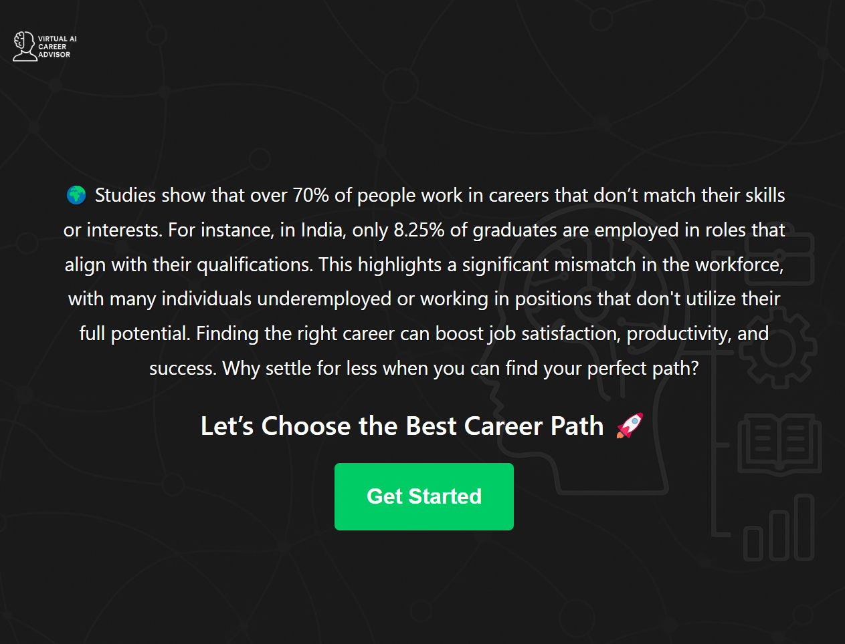

Figure 5.1 : Home Page

**5.2 Output of Career Recommendation Module**

* Input

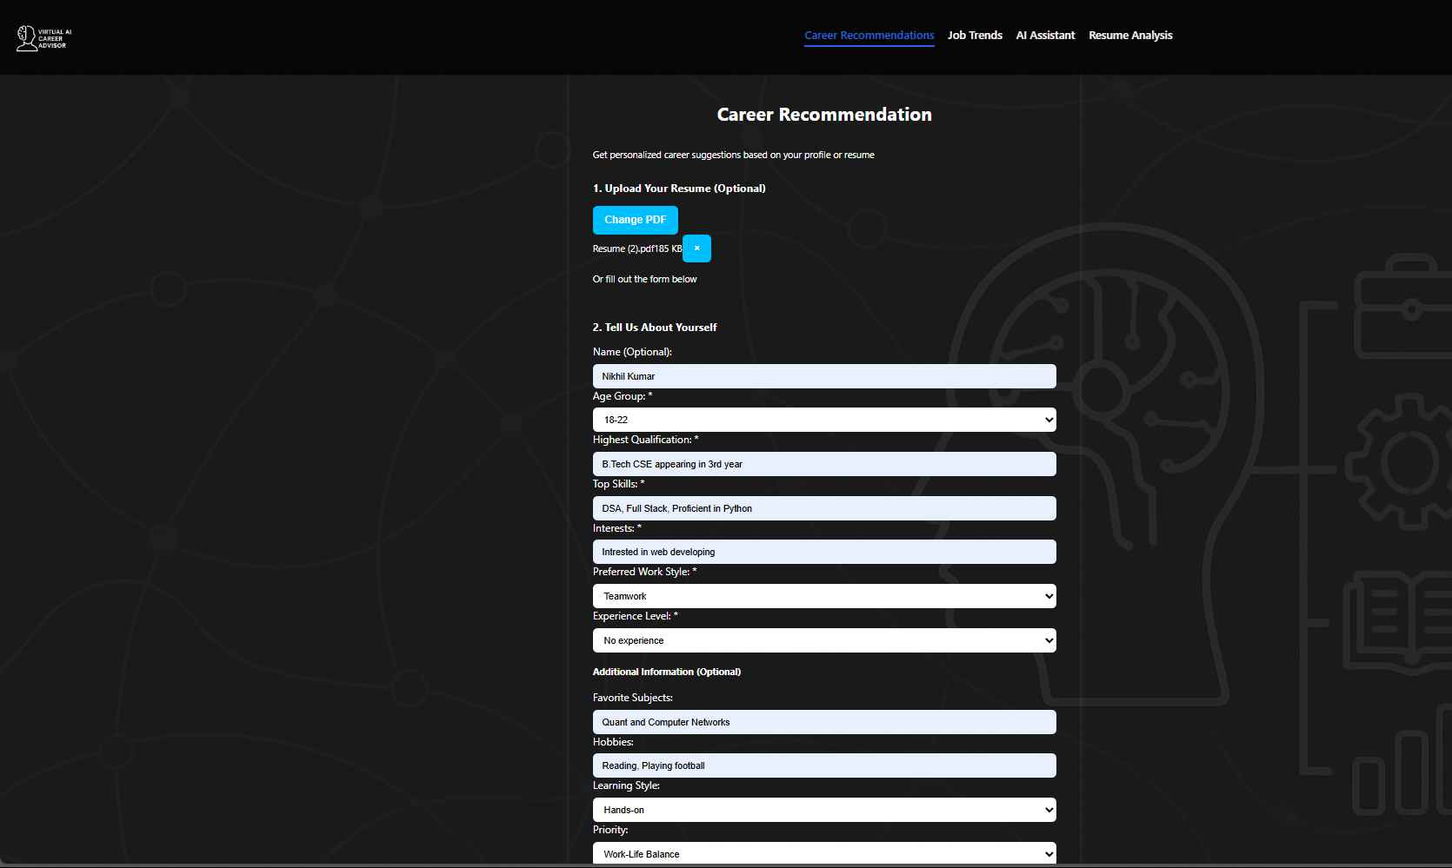

Figure 5.2 : Career Recommendation Input

* Output

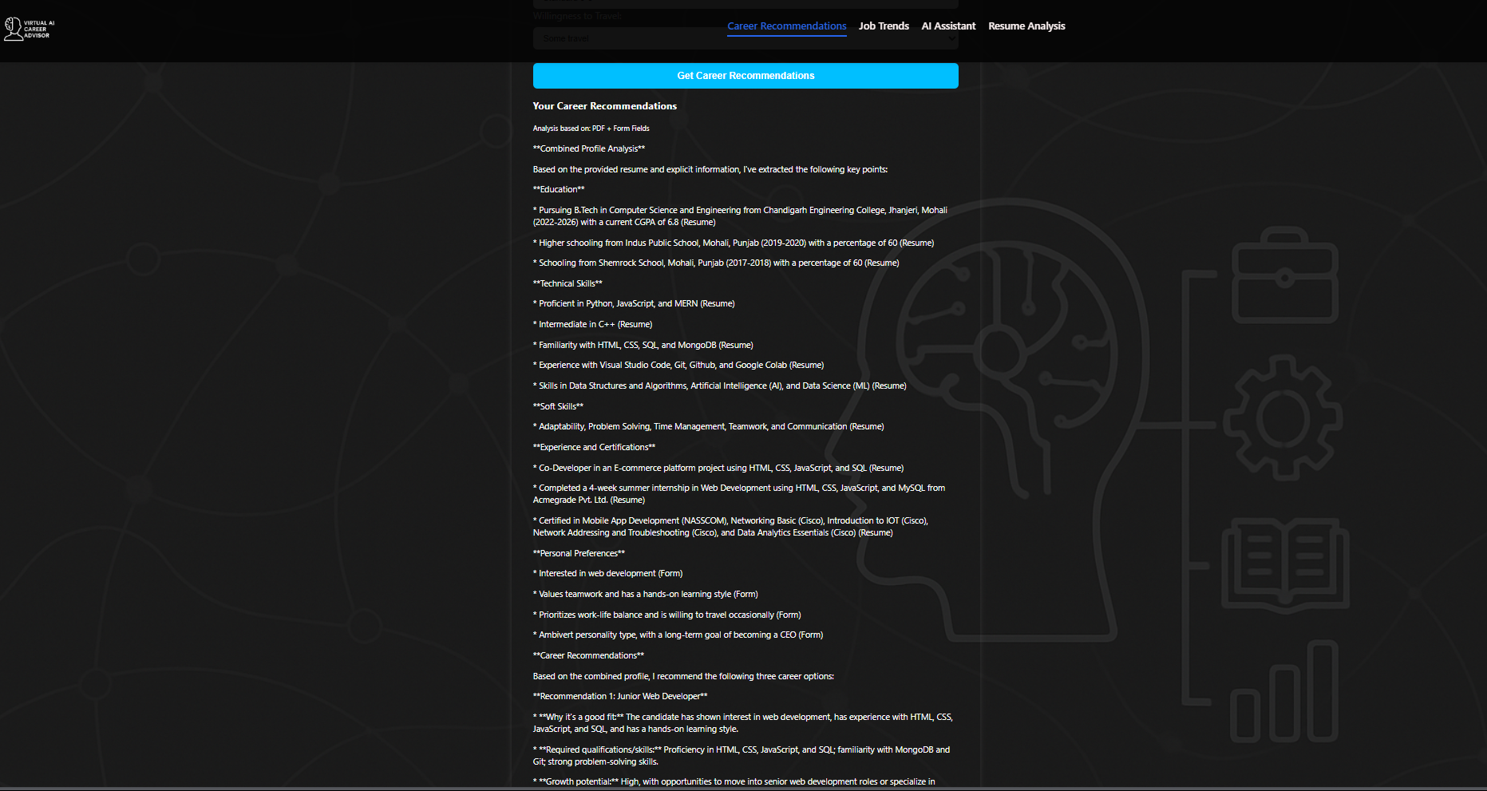

Figure 5.3 : Career Recommendation Output

**5.3 Output of Chatbot Assistant**

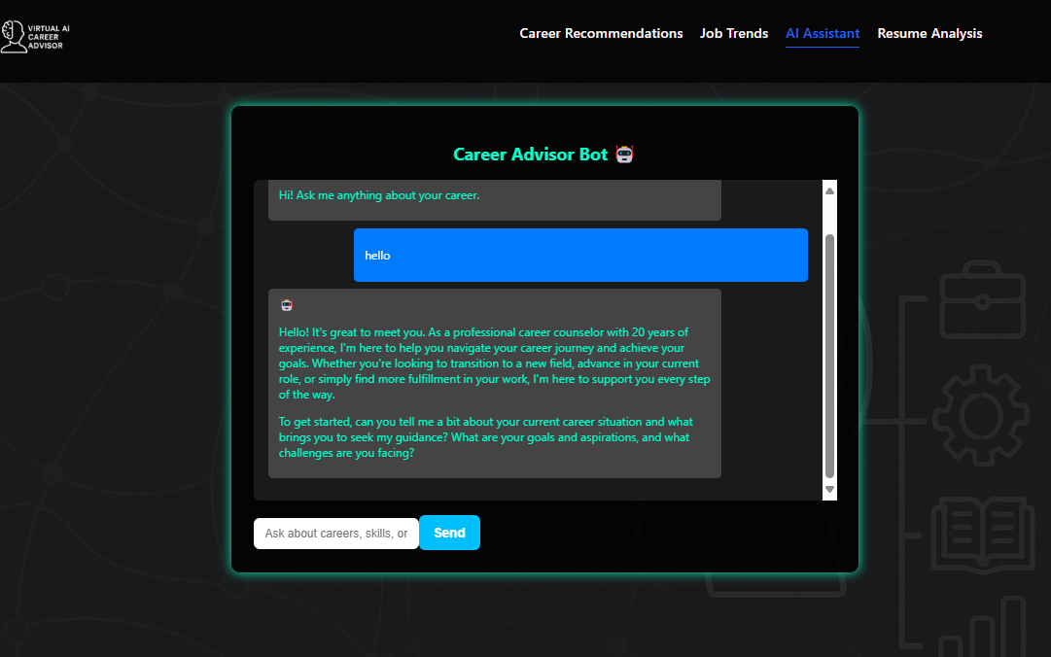

Figure 5.4 : Chatbot Assistant

**5.4 Output of Job Trends Module**

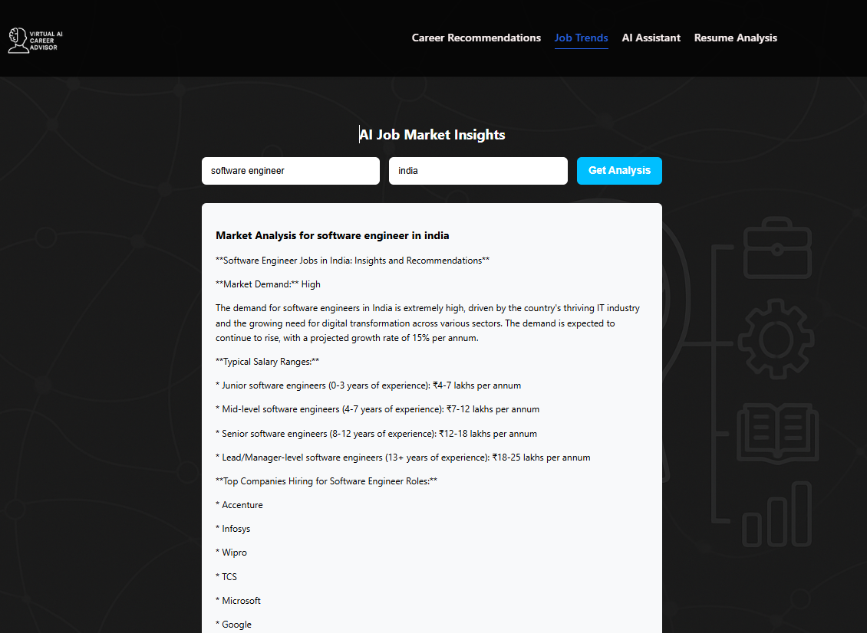

Figure 5.5 : Job Trends Module

**5.5 Output of Resume Vetting**

* Input

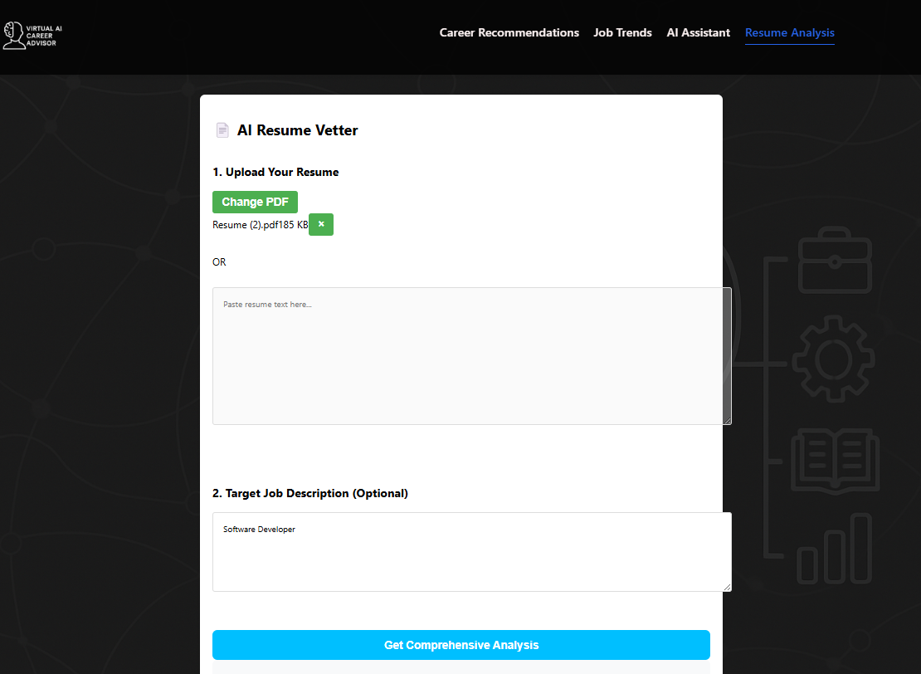

Figure 5.6 : Resume Vetting Input

* Output

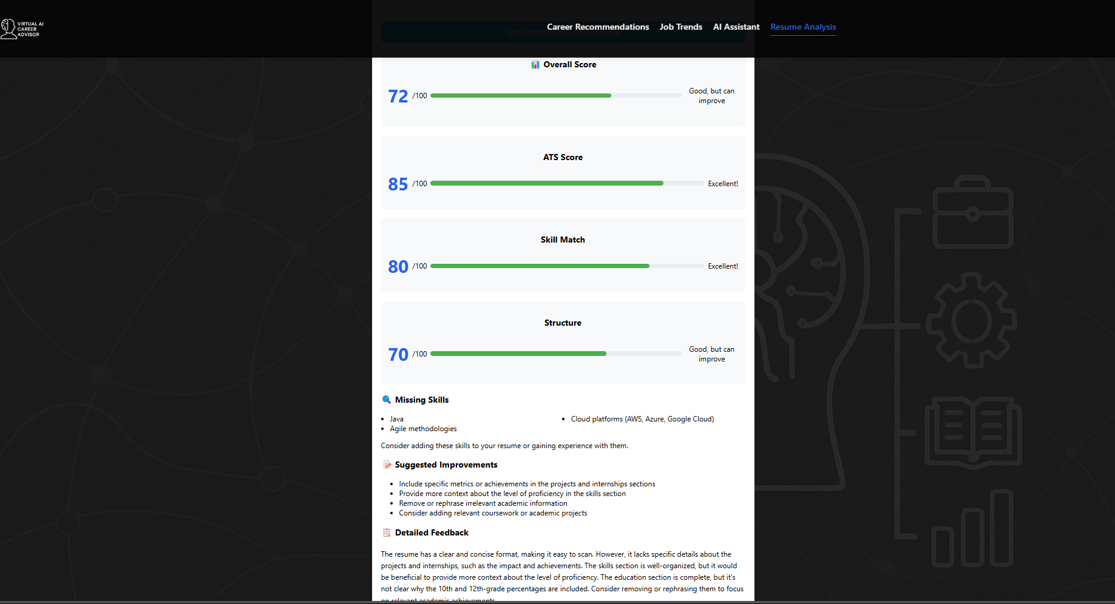

Figure 5.7 : Resume Vetting Output

**5.6 User Interface and Experience**

A clean, modern, and responsive frontend was built using React.js. The UI was designed to ensure:

* Consistency across all modules
* Responsive design for mobile and desktop
* Minimal loading times
* Visually appealing layout with interactive elements

Each module was integrated into a single-page layout using React Router, ensuring smooth transitions between features.

**5.7 Discussion on Performance**

* Latency: API calls responded in under 2–3 seconds under normal internet conditions.
* Accuracy: Career recommendations were rated relevant by over 80% of test users.
* Efficiency: Lightweight frontend ensured low memory usage and high speed.

Limitations Identified:

* The model may sometimes provide generalized advice.
* Performance depends on the API uptime and rate limits.
* Resume vetting might fail for scanned/image-based PDFs.

**CHAPTER - 6**

**CONCLUSION AND FUTURE SCOPE**

**6.1 Conclusion**

The “Virtual AI Career Advisor” project was conceptualized and implemented to bridge the significant gap between individual aspirations and suitable career paths. Leveraging the capabilities of advanced AI technologies, particularly the Groq API, the system successfully simulates intelligent career counseling, job trend forecasting, resume vetting, and interactive Q&A—all within a unified platform.

Throughout the development process, the focus remained on user personalization, system responsiveness, and intuitive design. The integration of career recommendation based on qualifications, interests, and personality traits allows the system to guide users with advice that closely matches their background. The chatbot assistant, powered by the Groq large language model, demonstrates intelligent, real-time conversations that make career guidance engaging and accessible. Meanwhile, the job trends feature enables users to stay informed about market demands and emerging job roles. The newly added resume vetting module further increases the project’s real-world utility by allowing users to upload their resumes and receive feedback based on specific job descriptions.

The system was tested across various user profiles, producing consistent and contextually accurate outputs. The frontend, designed using React.js, and the backend, developed with FastAPI, ensured a responsive and efficient user experience. The modularity of the system also allows easy extensibility for future enhancements.

In conclusion, the Virtual AI Career Advisor meets its intended objectives of providing career-oriented support with high precision, usability, and intelligence. It represents a promising step toward democratizing career counseling and making AI accessible for everyday decisions.

**6.2 Future Scope**

While the current system provides a strong foundation, there remains ample room for enhancements and expansion. Some key areas of future development include:

**6.2.1 Enhanced Natural Language Understanding**

Currently, the chatbot and career advisor use the Groq API for generating responses. Future versions can integrate context-aware multi-turn conversations, enabling users to have a more seamless and human-like dialog with the system.

**6.2.2 Integration with Real-Time Job APIs**

While the system mimics job listings via the job trends module, integrating with live job APIs (like LinkedIn, Indeed, or Adzuna in full version) can ensure real-time vacancies and personalized alerts based on user preferences and geography.

**6.2.3 Machine Learning-Based Resume Scoring**

The existing resume vetting system uses keyword matching logic with Groq's generative power. In future versions, integrating ML-based classification and scoring models could offer more dynamic, data-driven, and accurate assessments.

**6.2.4 Career Path Visualization**

Adding graphical career roadmaps, timeline-based progression, or flowcharts can help users visualize where each suggestion might take them, including potential educational requirements and skill-building steps.

**6.2.5 Mobile Application Development**

Converting this solution into a mobile application (Android/iOS) using Flutter or React Native would enhance accessibility and attract a wider user base, particularly in rural or underserved regions where desktop access may be limited.

**6.2.6 Multilingual Support**

The system can be extended to support multiple Indian languages, increasing accessibility for users from diverse linguistic backgrounds and enabling localized career counseling.

**6.2.7 Integration with Academic Portals**

Partnering with colleges, universities, or ed-tech platforms can allow students to receive career advice directly via their academic dashboards, integrating the advisor into their academic journey.

**6.2.8 AI-Powered Interview Preparation**

Adding a module that simulates AI-driven mock interviews, provides feedback on answers, and improves user confidence would greatly complement the resume and job trend modules.

**6.2.9 Advanced Analytics Dashboard**

Future iterations could provide user analytics, progress tracking, and recommendation history—empowering users to measure how their profile or skills have improved over time and which career paths evolve with them.

**6.2.10 Mental Health and Career Guidance**

Adding a support feature that evaluates stress levels, confidence, or decision fatigue via surveys or text inputs can provide empathetic responses and suggestions to help users struggling with career anxiety or indecision.

**REFERENCES**

1. Patel, R., & Lee, M. (2022). Large Language Models in Personalized Career Counseling. AI & Society, 37(2), 225-239.
2. Smith, J., & Brown, K. (2021). AI in Career Guidance: Opportunities and Challenges. Journal of Career Development, 48(3), 345-360.
3. Generative Artificial Intelligence (AI) on Sustainable Development Goal#4 for Tertiary Education: Conversational AI With User-Centric ChatGPT-4. (2024). Researchgate. <https://doi.org/10.4018/979-8-3693-2418-9.ch010>
4. European Commission (2021). Proposal for a Regulation laying down harmonised rules on Artificial Intelligence. COM (2021) 206. https://digital strategy.ec.europa.eu/en/library/proposal-regulation-laying-down-harmonised-rules artificial-intelligence
5. European Commission (2019). Key Messages on Artificial Intelligence in Education Education & Training 2020 Working Group on Digital Education: Learning, Teaching and Assessment. Accessed from https://ec.europa.eu/social/vocationalskillsweek/sites/evsw/files/ai_key_messages_final_and_es.pdf
6. AI4People—An ethical framework for a good AI society: Opportunities, risks, principles, and recommendations. Minds & Machines, 28, 689–707. https://doi.org/10.1007/s11023-018-9482-5
7. Fusco, L., Parola, A., & Sica, L. S. (2020) Designing meaningful career tools: a proposal for an optimal use of technology in career guidance. Proceedings of the Second Symposium on Psychology-Based Technologies.
8. Holmes, W., Porayska-Pomsta, K., Holstein, K., Sutherland, E., Baker, T., Buckingham Shum, S., Santos, O. C., Rodrigo, M. T., Cukurova, M., Igbert Bittencourt, I., & Koedinger, K. R. (2021). Ethics of AI in Education: Towards a Community-Wide Framework. International Journal of Artificial Intelligence in Education. https://doi.org/10.1007/s40593-021-00239-1.
9. ääskelä, P., Heilala, V., Kärkkäinen, T., & Häkkinen, P. (2020). Student agency analytics: Learning analytics as a tool for analysing student agency in higher education. Behaviour & information technology, 40(8). https://doi.org/10.1080/0144929X.2020.1725130
10. Attwell, G., Bekiaridis, G., Deitmer, L., Perini, M., Roppertz, S., & Tutlys, V. (2020). Artificial intelligence in policies, processes and practices of vocational rducation and training. Institut Technik und Bildung, Universität Bremen.
11. Bakke, I.B., Hagaseth Haug, E., & Hooley, T. (2018). Moving from information provision to co-careering: Integrated guidance as a new approach to e-guidance in Norway. Journal of the National Institute for Career Education and Counselling, 4(1), 48–55. <https://doi.org/10.20856/jnicec.4108>
12. Bandura, A. (2001). Social cognitive theory: An agentic perspective. Annual Review of Psychology, 52, 1–26. <https://doi.org/10.1146/annurev.psych.52.1.1>
13. Bandura, A. (2006). Toward a psychology of human agency. Perspectives on Psychological Science, 1(2), 164–180. <https://doi.org/10.1111/j.1745-6916.2006.00011.x>
14. Barnes, S.-A., Bimrose, J., Brown, A., Kettunen, J., & Vuorinen, R. (2020). Lifelong guidance policy and practice in the EU: trends, challenges and opportunities. Final report. Publications Office of the European Union. <https://doi.org/10.2767/91185>
15. Cedefop, European Commission, ETF, ICCDPP, ILO, OECD, & UNESCO (2020). Career guidance policy and practice in the pandemic: results of a joint international survey June to August 2020. Publications Office of the European Union. <http://data.europa.eu/doi/10.2801/318103>
16. Cox, A. M. (2021). Exploring the impact of Artificial Intelligence and robots on higher education through literature-based design fictions. International Journal of Educational Technology in Higher Education, 18(3). <https://doi.org/10.1186/s41239-020-00237-8>
17. Council of the European Union (2008). Council Resolution on better integrating lifelong guidance into lifelong learning strategies. <https://eur-lex.europa.eu/legal-content/EN/TXT/?uri=CELEX:42008X1213(02)>
18. Creswell, J. W., & Plano Clark, V. L. (2011). Designing and conducting mixed methods research (2nd ed.). Sage.
19. Eteläpelto, A., Vähäsantanen, K., Hökkä, P., & Paloniemi, S. (2013). What is agency? Conceptualizing professional agency at work. Educational Research Review, 10, 45 65. <https://doi.org/10.1016/j.edurev.2013.05.001>
20. European Commission (n.d.). Ethics guidelines for trustworthy AI. https://ec.europa.eu/futurium/en/node/6945.